Unit 1 Review AP Statistics Name ___________

1. Indicate the type of variable:

Hyundai car models

Number of hurricanes

Room number

Weight of a newborn

2. Indicate what type of graphs would be appropriate to display the following variables

1. Percentages of Hyundai models sold by a dealership
2. Weights of newborns at Kennestone Hospital this month

3.

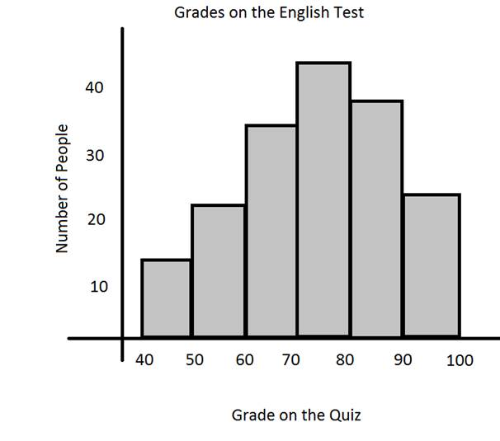

1. What is the shape?
2. Will the mean be the same as the median, larger or smaller?
3. Which measure of center would be better to summarize this data?

4.

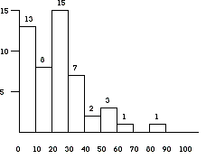

1. What is the shape?
2. Will the mean be the same as the median, larger or smaller?
3. Which measure of center would be better to summarize this data?

5.. The five-number summary of salaries (in millions) for 20 NBA players is

|  |  |  |  |  |
| --- | --- | --- | --- | --- |
| Min | Q1 | Median | Q3 | Max |
| 0.5 | 2.6 | 3.2 | 3.9 | 9.0 |

Are there any outliers on the low or high ends of the data? Show how you determined this.

6. Grades on a Geometry test for 20 students were the following

71 72 67 65 100 83 69 61 72 68

65 81 75 68 75 66 77 61 64 74

a. Sketch a histogram for these data using a class size of 5.

b. Find the mean for the grades.

c. Find the 5 number summery and the IQR for the grades.

d. Sketch a boxplot for these data.

7. A new weed killer was being tested. The five-number summary for the percentage of weeds in 50 plots is:

|  |  |  |  |  |
| --- | --- | --- | --- | --- |
| Min | Q1 | Median | Q3 | Max |
| 5 | 10 | 15 | 27 | 50 |

Suppose the researcher made a mistake. The 50 was entered wrong and should have been a 20. Indicate how changing the percentage for that reading should make each of the following summary statistics increase, decrease, or stay about the same:

I mean ____________________________________

II median ____________________________________

III range ____________________________________

IV IQR ____________________________________