  - Tests About a Population Mean

Warmup

A researcher reports that the average salary of assistant professors is more than $42,000. A sample of 30 assistant professors has a mean salary of $43,260. At α = 0.05, test the claim that assistant professors earn more than $42,000 a year. The standard deviation for the salary of all assistant professors is $5,230.

Two-Sided Tests

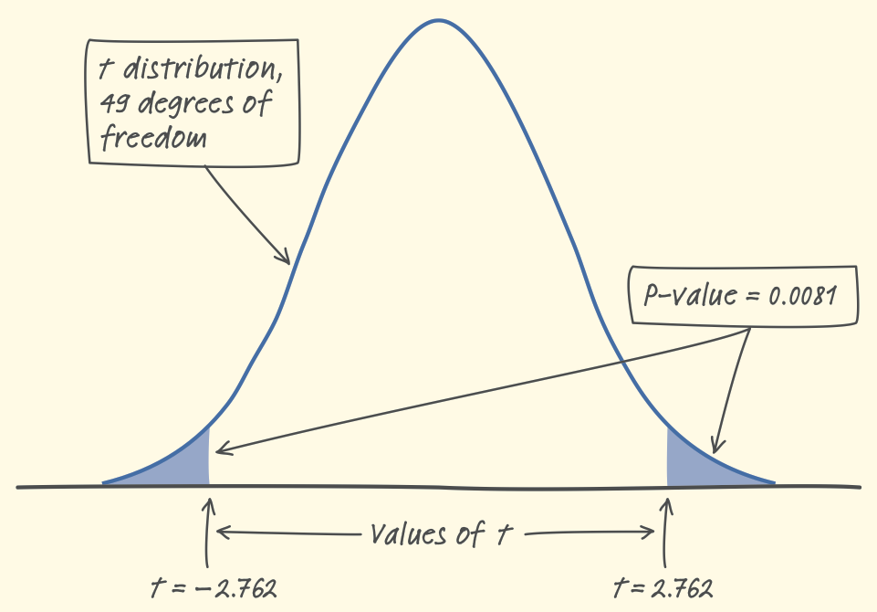
P-value Just like with z tests, two-sided t tests have two tails. Therefore, the P-value for this two-sided test is two times as large as for a similar one-sided test. The 2-tail line at the top of the t-distribution table makes this adjustment for you

Example:

At the Hawaii Pineapple Company, last year the mean weight of the pineapples harvested from one large field was 31 ounces. A new irrigation system was installed in this field after the growing season. Managers wonder whether this change affected the mean weight of pineapples grown in the field. To find out, they select and weigh a random sample of 50 pineapples from this year’s crop. The mean weight for the sample was 31.935 ounces with a standard deviation of 2.394 ounces. Conduct a significance test to see if there is enough evidence that the weight is different.

State:

Conditions:

Calculate

Interpret
Confidence Intervals and Two-Sided Tests

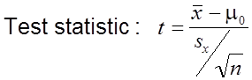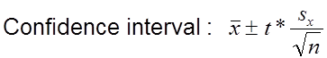

- A two-sided test at significance level α (say, α = 0.05) and a 100(1 – α)% confidence interval (a 95% confidence interval if α = 0.05) give similar information about the population parameter.
- When the two-sided significance test at level α rejects H₀: µ = µ₀, the 100(1 – α)% confidence interval for µ will not contain the hypothesized value µ₀ .
- When the two-sided significance test at level α fails to reject the null hypothesis, the confidence interval for µ will contain µ₀

Example (cont’d):

Construct a 95% confidence interval for the mean weight of all the pineapples grown in the field this year.

For the pineapples, the two-sided test at α =0.05 rejects H₀: µ = 31 in favor of H_{a}: µ ≠ 31. The corresponding 95% confidence interval does not include 31 as a plausible value of the parameter µ. In other words, the test and interval lead to the same conclusion about H₀. But the confidence interval provides much more information: a set of plausible values for the population mean.

Example: Earnings

US data for male median earnings indicates that this figure is $33,000. What can you say about the validity this figure if a simple random sample of 200 men showed an average earnings level of $31,500, with a standard deviation of $5,000? Use a .10 level of significance.

Construct an appropriate confidence interval. Are the results consistent with the significance test?

Paired t Test

Comparative studies are more convincing than single-sample investigations. For that reason, one-sample inference is less common than comparative inference. Study designs that involve making two observations on the same individual, or one observation on each of two similar individuals, result in paired data.

When paired data result from measuring the same quantitative variable twice, as in the job satisfaction study, we can make comparisons by analyzing the differences in each pair. If the conditions for inference are met, we can use one-sample t procedures to perform inference about the mean difference µ_{d}.
These methods are sometimes called paired t procedures.

Example

Researchers designed an experiment to study the effects of caffeine withdrawal. They recruited 11 volunteers who were diagnosed as being caffeine dependent to serve as subjects. Each subject was barred from coffee, colas, and other substances with caffeine for the duration of the experiment. During one two-day period, subjects took capsules containing their normal caffeine intake. During another two-day period, they took placebo capsules. The order in which subjects took caffeine and the placebo was randomized. At the end of each two-day period, a test for depression was given to all 11 subjects. Researchers wanted to know whether being deprived of caffeine would lead to an increase in depression.
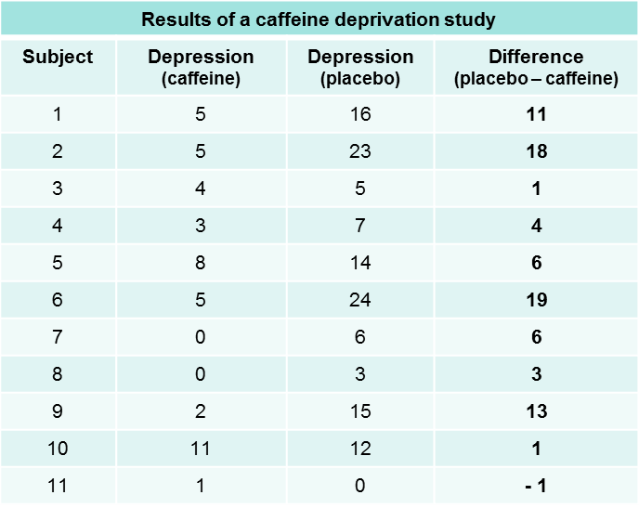

Example Is the express lane faster?

For their second semester project in AP Statistics, Libby and Kathryn decided to investigate which line was faster in the supermarket, the express lane or the regular lane. To collect their data, they randomly selected 15 times during a week, went to the same store, and bought the same item. However, one of them used the express lane and the other used a regular lane. To decide which lane each of them would use, they flipped a coin. If it was heads, Libby used the express lane and Kathryn used the regular lane. If it was tails, Libby used the regular lane and Kathryn used the express lane. They entered their randomly assigned lanes at the same time and each recorded the time in seconds it took them to complete the transaction.

Time in  Express Lane  (seconds) | Time in  Regular Lane  (seconds)
337 | 342
226 | 472
502 | 456
408 | 529
151 | 181
284 | 339
150 | 229
357 | 263
349 | 332
257 | 352
321 | 341
383 | 397
565 | 694
363 | 324
85 | 127

Problem: Carry out a test to see if there is convincing evidence that the express lane is faster. (Remember, faster time means less)

