* 1. **Tests About a Population Mean**

**Carrying Out a Significance Test for µ**

In an earlier example, a company claimed to have developed a new AAA battery that lasts longer than its regular AAA batteries. Based on years of experience, the company knows that its regular AAA batteries last for 30 hours of continuous use, on average. An SRS of 15 new batteries lasted an average of 33.9 hours with a standard deviation of 9.8 hours. Do these data give convincing evidence that the new batteries last longer on average?

**Step 1: State the hypotheses and parameter of interest**

**Step 2: Check the conditions**

Three conditions should be met before we perform inference for an unknown population mean: Random, Normal, and Independent. The Normal condition for means is:

Population distribution is Normal or sample size is large (*n* ≥ 30)

**Step 3: Calculate the test statistic and find the p-value**

For a test of *H0*: *µ* = *µ0*

Because the population standard deviation σ is usually unknown, we use the sample standard deviation *sx*.

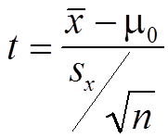

This statistic has a t distribution with n - 1 degrees of freedom. You will find a range for the p-value in the t-table.

**Step 4: Interpret the result in context of the problem**

**Using Table B Wisely**

* Table B gives a range of possible *P*-values for a significance. We can still draw a conclusion from the test in much the same way as if we had a single probability by comparing the range of possible *P*-values to our desired significance level.
* Table B shows probabilities only for positive values of *t*. To find a *P*-value for a negative value of *t*, we use the symmetry of the *t* distributions.

**Example**: Student IQs

Bon Air Elementary School has 300 students. The principal of the school thinks that the average IQ of students at Bon Air is higher than the national average of 100. To prove her point, she administers an IQ test to 30 randomly selected students. Among the sampled students, the average IQ is 108 with a standard deviation of 15. Based on these results, should the principal accept or reject her original hypothesis? Assume a significance level of 0.01.

**Example:** Fuel Economy

Suppose that an automobile manufacturer advertises that its new hybrid car has a mean gas mileage of 50 miles per gallon. A consumer’s group thinks that this claim is too high. They take a simple random sample of n = 30 hybrid vehicles and test their gas mileage. In this sample, the average is 47 miles per gallon with a standard deviation of 5.5 miles per gallon. Do we have enough evidence that the consumer group is correct at a 5% significance level?

**Significance Test with known σ**

For a test of *H0*: *µ* = *µ0*, our statistic is the sample mean

If the population standard deviation σ is known, we calculate the z-score for the test statistic



We use the same procedure we learned with proportions to determine the p-value, based on the sign of the alternate hypothesis.

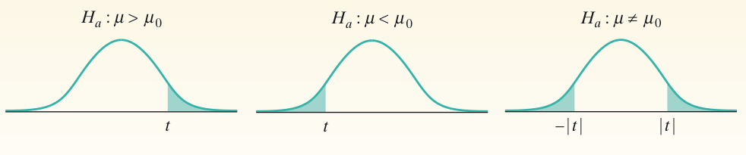

**Example: Conductors**

Do male symphony conductors live longer, on average, than males in the general population? The mean life span for 35 male symphony conductors was 73.4 years, in contrast to the mean of 69.5 years for males in the general population. Assuming that the 35 conductors is a random sample, and that σ = 8.7 years, test the claim that the conductors have a longer average life span. Use a significance level of α = 0.05.

**Example: Emissions**

The EPA reports that the exhaust emissions for a certain car model has a normal distribution with a mean of 1.45 grams of nitrous oxide per mile and a standard deviation of 0.4. The car manufacturer claims their new process reduces the mean level of exhaust emitted for this car model. A SRS of 28 cars is taken and the mean level of exhaust emitted for this sample is 1.21 grams. Perform a significance test with α = 0.01.