Practice Test 8 AP Statistics Name:

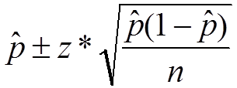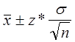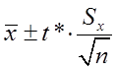
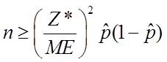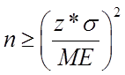

Part 1: Multiple Choice. Circle the letter corresponding to the best answer.

- Find the critical value (z* ) for a 70% confidence level.

- What is the effect of the following on a confidence interval:

- Increase sample size from 50 to 100

- Decrease confidence level from 95% to 90%

- Many television viewers express doubts about the validity of certain commercials. In an attempt to answer their critics, the Timex Corporation wishes to estimate the proportion of consumers who believe what is shown in Timex television commercials. Let p represent the true proportion of consumers who believe what is shown in Timex television commercials. If Timex has no prior information regarding the true value of p, how many consumers should be included in their sample so that they will be 90% confident that their estimate is within 0.05 of the true value of p?

- Suppose we want a 90% confidence interval for the average amount spent on books by freshmen in their first year at a major university. The interval is to have a margin of error of $2, and the amount spent has a Normal distribution with a standard deviation = $30. How many freshmen need to be included in the sample?

- The effect of video game playing on grades is a concern of educators. In order to determine baseline yields, a random sample of 20 students was selected, and the weekly playing time was determined. The sample had a mean of 12.21 hours. A previous study found the standard deviation for all students was 5.45. Find a 99% confidence interval for the mean playing time.

6. You measure the weights of 24 male runners, which are normally distributed. You do not actually choose an SRS, but you are willing to assume that these runners are a random sample from the population of male runners in your town or city. The mean weight of the runners in the sample was 157.4 lbs. A previous study found the standard deviation for the runners’ weight was 5.7 lbs.

Construct and interpret a 95% confidence interval for , the mean weight of all male runners. Follow the 4-Step Process (State your plan; check conditions; calculate; interpret)

- You want to conduct a poll at your school to estimate the proportion of students in your school who have outside jobs in the evenings and on weekends. There are 2,100 students at the school. You select an SRS of 60 students and 37% respond that they have an outside job. Construct a 90% confidence interval for the actual proportion of students at the school who have an outside job. Follow the 4-Step Process (State your plan; check conditions; calculate; interpret)

