5.1 Randomness, Probability and Simulation
Probability: What Are the Chances?
As a special promotion for its 20-ounce bottles of soda, a soft drink company printed a message on the inside of each bottle cap. Some of the caps said, “Please try again.” While others said, “You’re a Winner.” The company advertised the promotion with the slogan, “1 in 6 wins a prize!” Seven friends each buy one 20-ounce bottle at a local convenience store. The store clerk is surprised when three of them win a prize. Is this group of friends just lucky or is the company’s claim inaccurate? Let’s assume the company is telling the truth, and that every 20-ounce bottle of soda it fills has a 1 in 6 chance of getting a winning cap. We can model the status of an individual’s bottle using a normal 6-sided die. Let 1-5 represent, “Try Again” and 6 represent “You’re a Winner”
(1) Roll your die 7 times to imitate the outcome of the seven friends. Record how many winners
(2) Repeat step (1) four more times recording each result.
(3) Record your results on the class graph.
(4) Based on the class result, does it seem plausible that the company is telling the truth? Did the seven friends just get lucky?
The Idea of Probability
Chance behavior is unpredictable in the short run, but has a regular and predictable pattern in the long run.
The law of large numbers says that if we observe more and more repetitions of any chance process, the proportion of times that a specific outcome occurs approaches a single value.
The probability of any outcome of a chance process is a number between 0 (never occurs) and 1(always occurs) that describes the proportion of times the outcome would occur in a very long series of repetitions.

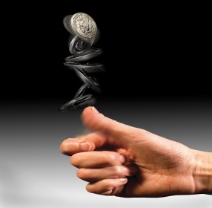
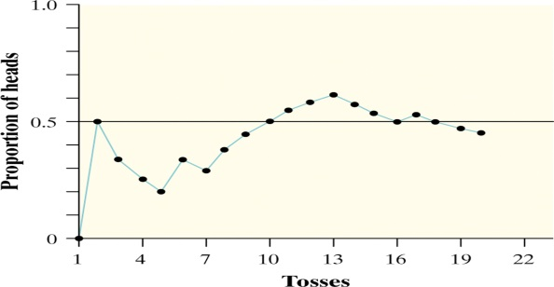
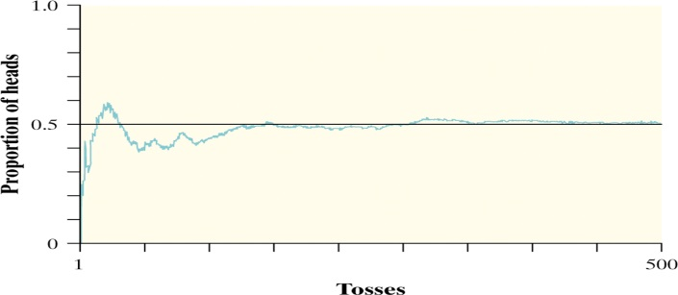

Probability Applet
If you toss a fair coin 10 times, how many heads would you expect?
On the iPad, open the Safari browser and go to http://www.rossmanchance.com
Click “Rossman/Chance Applet Collection” then “One Proportion Inference” under Statistical Inference
- Set the number of tosses at 10 and click “Draw sample”.What proportion of heads did you get?
Click “Draw sample” several more times. What do you notice about the proportion of heads?
- Set the number of tosses at 100 and click “Draw sample”.What proportion of heads did you get?
Click “Draw sample” several more times. What do you notice about the proportion of heads?
What difference with the proportions did you notice comparing the 10 tosses and the 100 tosses?
What would happen if you had an unfair coin?
- Set the probability of heads to .3 and the number of tosses at 100 and click “Draw sample”. What proportion of heads did you get?
Click “Draw sample” several more times. What do you notice about the proportion of heads?

Probability
Probability is a measure of how likely an outcome is to occur. Match one of the probabilities that follow with each statement. Be prepared to explain.
0 0.01 0.3 0.6 .99 1
(a) The outcome is impossible. Will never happen.
(b) The outcome is certain. Will always happen.
(c) This outcome is very unlikely, but it will occur once in a while in a long sequence of trials.
(d) This outcome will occur more often than not.

Simulation
The imitation of chance behavior, based on a model that accurately reflects the situation, is called a simulation.
Performing a Simulation
- State: What is the question of interest about some chance process?
- Plan: Describe how to use a chance device to imitate one repetition of the process. Explain clearly how to identify the outcomes of the chance process and what variable to measure.
- Do: Perform many repetitions of the simulation.
- Conclude: Use the results of your simulation to answer the question of interest.
We can use physical devices, random numbers (e.g. Table D), and technology to perform simulations.
Example 1:

At a local high school, 95 students have permission to park on campus. Each month the student council holds a “golden ticket parking lottery” at a school assembly. The two lucky winners are given reserved parking spots next to the school’s main entrance. Last month, the winning tickets were drawn by a student council member for two students in the AP Statistics class. When both golden tickets went to members of that same class, some people thought the lottery had been rigged since the student council member was also in the class. There are 28 students in the AP Statistics class, all of whom are eligible to park on campus. Design and carry out a simulation to decide whether it’s plausible that the lottery was carried out fairly. Use line 139 in Table D.

Example 2:
In an attempt to increase sales, a breakfast cereal company decides to offer a NASCAR promotion. Each box of cereal will contain a collectible card featuring one of these NASCAR drivers: Jeff Gordon, Dale Earnhardt, Jr., Tony Stewart, Danica Patrick, or Jimmie Johnson. The company says that each of the cards is equally likely to appear in any box of cereal. A NASCAR fan decides to keep buying boxes of cereal until she has all 5 drivers’ cards. She is surprised when it takes her 23 boxes to get the full set of cards. Design and carry out a simulation to decide what is the probability it would take at least 23 boxes to get all 5 cards. Use the randint function on your calculator.

