3.1 Scatterplots and Correlation
What is the difference between a response variable and the explanatory variable?
A response variable measures an outcome of a study. An explanatory variable may help explain or influence changes in a response variable.
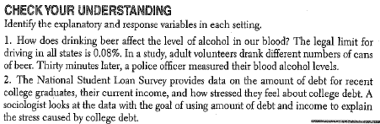
Scatterplots
The most useful graph for displaying the relationship between two quantitative variables is a scatterplot. A scatterplot shows the relationship between two quantitative variables measured on the same individuals. The values of one variable appear on the horizontal axis, and the values of the other variable appear on the vertical axis. Each individual in the data appears as a point on the graph.
How to Make a Scatterplot
- Decide which variable should go on each axis.
  - Remember, the eXplanatory variable goes on the X-axis!
- Label and scale your axes.
- Plot individual data values.
Make a scatterplot of the relationship between body weight and pack weight.
Body weight (lb) | 120 | 187 | 109 | 103 | 131 | 165 | 158 | 116
Backpack weight (lb) | 26 | 30 | 26 | 24 | 29 | 35 | 31 | 28

