Section 7.2 - Sample Proportions (pp. 432-441)
1. The Sampling Distribution of $\hat{p}$
Let’s turn once again to the hyena experiment . Suppose a team took one sample and found the proportion of males to be $\hat{p}$ =0.20. Since another random sample would likely result in a different estimate, we can only say that “about” 20% of the population of hyenas in the Croatan NF are males. In this section, we are going to use sampling distributions to clarify what “about” means.Activity
Suppose a team performed the hyena experiment again. First they chose repeated samples of size 5. The distribution of sample proportions is shown at the right.  Describe the shape: | 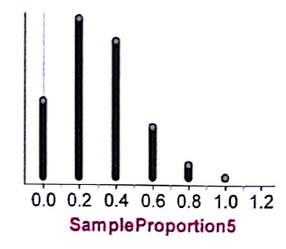
The team then took repeated samples of size 10. The distribution of sample proportions is shown at the right.  Describe the shape: | 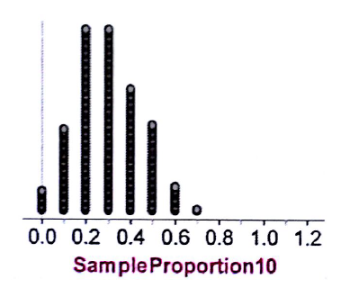
Finally, the team took repeated samples of size 20. The distribution of sample proportions is shown at the right.  Describe the shape: | 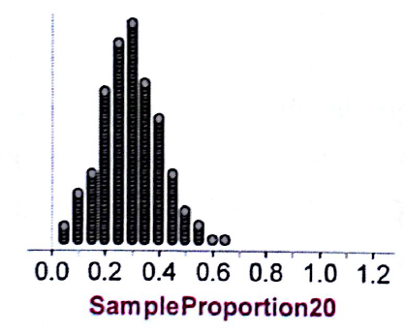
Summarize what happened to the center, shape and spread as the sample size was increased from 5 to 20.
Binomial Distribution - Is the hyena experiment binomial? Let X = the number of males obtained in each sample. Is X a binomial random variable?
B:
I:
N:
S:

This means that $\hat{p}$ =
From Chapter 6, we know that the mean and standard deviation of a binomial random variable X are:
$μ_{X}$ = and $σ_{X}$ =

Sampling Distribution of a Sample Proportion

Choose an SRS of size n from a population of size N with proportion p of successes. Let $\hat{p}$ be the sample proportion of successes. Then:

- The mean of the sampling distribution of $\hat{p}$ is

- The standard deviation of the sampling distribution of $\hat{p}$ is

as long as the 10% condition is satisfied: n≤(1/10)N.

- As n increases, the sampling distribution of $\hat{p}$ becomes approximately Normal. Before you perform Normal calculations, check that the Normal condition is satisfied: np ≥ 10 and  n(1-p)≥10. | 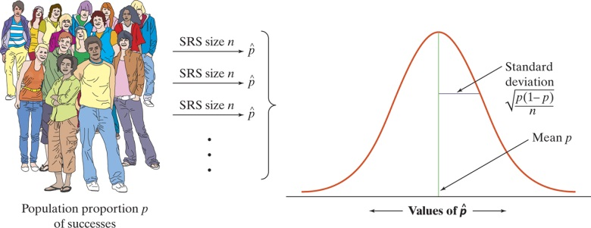
Check Your Understanding - About 75% of young adult internet users (ages 18-29) watch online video. Suppose that a sample survey contacts an SRS of 1000 young adult internet users and calculates the proportion $\hat{p}$ in this sample who watch online video.
(a) What is the mean of the sampling distribution of $\hat{p}$ ? Explain.

(b) Find the standard deviation of the sampling distribution of $\hat{p}$ . Check that the 10% condition is met.

(c) Is the sampling distribution of $\hat{p}$ approximately Normal? Check that the Normal condition is met.

(d) If the sample size were 9000 instead of 1000, how would this change the sampling distribution of $\hat{p}$ ?

2. Using the Normal Approximation of $\hat{p}$
Example #1
A polling organization asks an SRS of 1500 first-year college students how far away their home is. Suppose that 35% of all first-year students actually attend college within 50 miles of home. What is the probability that the random sample of 1500 students will give a result within 2 percentage points of this true value?

Example #2
The superintendent of a large school district wants to know what proportion of middle school students in her district are planning on attending a four-year college or university. Suppose that 80% of all middle school students in her district are planning to attend a four-year college or university. What is the probability that an SRS of size 125 will give a result within 7 percentage points of the true value?

