**Section 7.3 - Sample Means**

Sample proportions arise most often when we are interested in categorical variables. When we record quantitative variables we are interested in other statistics such as the median or mean or standard deviation of the variable. Sample means are among the most common statistics.

Consider the mean household earnings for samples of size 100. Compare the population distribution on the left with the sampling distribution on the right. What do you notice about the shape, center, and spread of each?

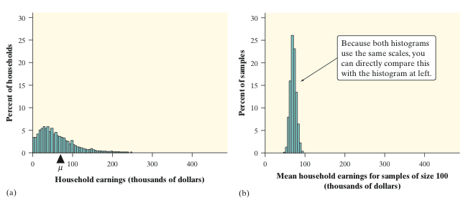

|  |  |
| --- | --- |
| **The Sampling Distribution of**  When we choose many SRSs from a population, the sampling distribution of the sample mean is centered at the population mean µ and is less spread out than the population distribution. Here are the facts.        as long as the *10% condition* is satisfied: *n* ≤ (1/10)*N*. |  |

**Sampling from a Normal Population**

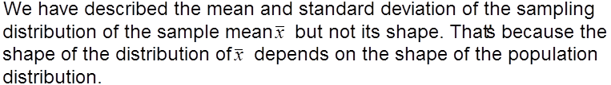

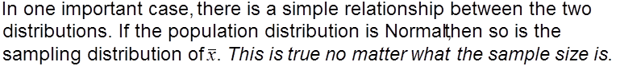



**Example: Young Women’s Heights**

The height of young women follows a Normal distribution with mean µ = 64.5 inches and standard deviation σ = 2.5 inches.

1. Find the probability that a randomly selected young woman is taller than 66.5 inches.

b) Find the probability that the mean height of an SRS of 10 young women exceeds 66.5 inches.

**Example: IQs**

IQ is normally distributed with a mean of 100 and standard deviation of 15.

1. What is the probability that a randomly chosen person will have an IQ of 95 or less?
2. What is the probability that the mean IQ of an SRS of 5 will be 95 or less?
3. Without doing the calculation, what would you expect for the probability that the mean IQ of an SRS of 15 will be 95 or less?

**The Central Limit Theorem**

It is a remarkable fact that as the sample size increases, the distribution of sample means changes its shape: it looks less like that of the population and more like a Normal distribution! When the sample is large enough, the distribution of sample means is very close to Normal, no matter what shape the population distribution has, as long as the population has a finite standard deviation.



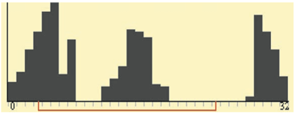

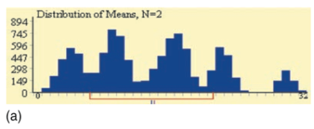

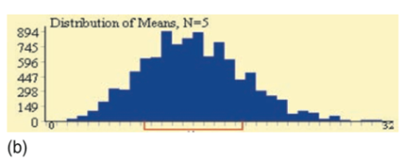

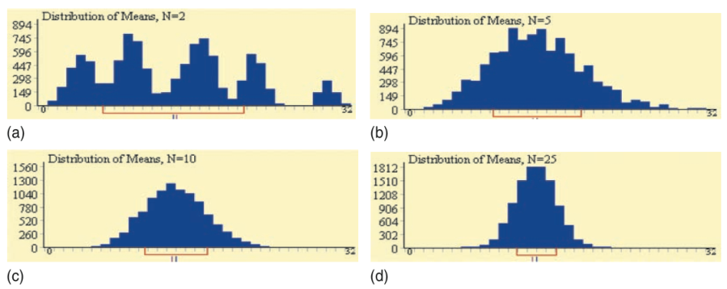

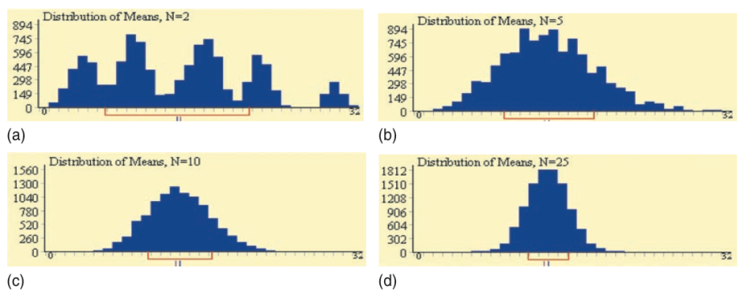

**Example: Servicing Air Conditioners**

Based on service records from the past year, the time (in hours) that a technician requires to complete preventative maintenance on an air conditioner follows the distribution that is strongly right-skewed, and whose most likely outcomes are close to 0. The mean time is µ = 1 hour and the standard deviation is σ = 1

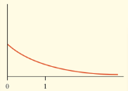

Your company will service an SRS of 70 air conditioners. You have budgeted 1.1 hours per unit. Will this be enough?

What if they budgeted 1.2 hours per unit?