5.2 Probability Rules

**Warmup**

The chance of winning a prize from Herff-Jones is 1/22. How would you set up a simulation using the random number table to determine the probability of a group of 5 friends winning at least 1 prize?

**Probability Models**

The **sample space *S*** of a chance process is the set of all possible outcomes.

A **probability model** is a description of some chance process that consists of two parts: a sample space *S* and a probability for each outcome.

**Example: Roll the Dice**

Give a probability model for the chance process of rolling two fair, six-sided dice

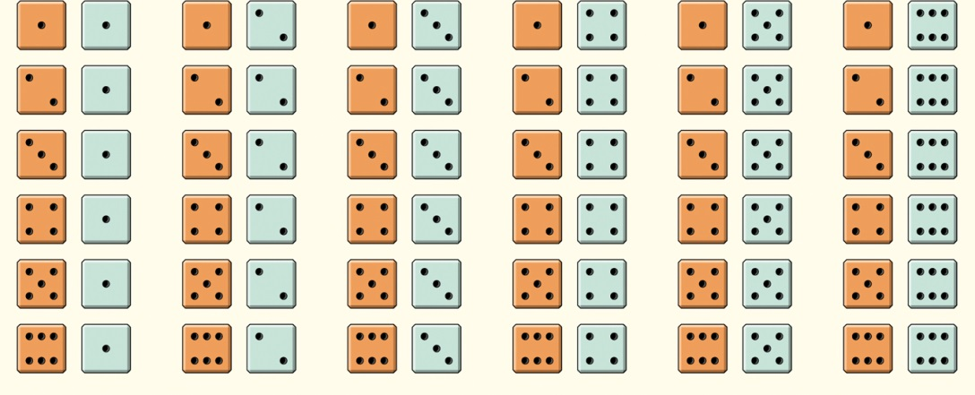

What is the sample space?

What is the probability of any specific outcome?

An **event** is any collection of outcomes from some chance process. That is, an event is a subset of the sample space. Events are usually designated by capital letters, like *A, B, C,* and so on.

If *A* is any event, we write its probability as P(*A*).

In the dice-rolling example, suppose we define event *A* as “sum is 5.” What is P(A)?

Event B is “sum not 5”. What is P(B)?

**Basic Rules of Probability**

* The probability of any event is a number between 0 and 1. 0 ≤ *P*(*A*) ≤ 1
* All possible outcomes together must have probabilities whose sum is 1. *P*(*S*) = 1
* If all outcomes in the sample space are equally likely, the probability that event *A* occurs can be found using the formula



* The probability that an event does not occur is 1 minus the probability that the event does occur. *P*(*AC*) = 1 – *P*(*A*)
* If two events have no outcomes in common, the probability that one or the other occurs is the sum of their individual probabilities. *P*(*A* or *B*) = *P*(*A*) + *P*(*B*)

Two events are **mutually exclusive** (disjoint) if they have no outcomes in common and so can never occur together.

**Example: Distance Learning**

Distance-learning courses are rapidly gaining popularity among college students. Randomly select an undergraduate student who is taking distance-learning courses for credit and record the student’s age. Here is the probability model:

|  |  |  |  |  |
| --- | --- | --- | --- | --- |
| **Age group (yr):** | 18 to 23 | 24 to 29 | 30 to 39 | 40 or over |
| **Probability:** | 0.57 | 0.17 | 0.14 | 0.12 |

1. Show that this is a legitimate probability model.
2. Find the probability that the chosen student is between 24 and 39 years old
3. Find the probability that the chosen student is not in the traditional college age group (18 to 23 years).

**Two-way Tables and Probability**

Students in a college class were surveyed about whether they had pierced ears. The results are:

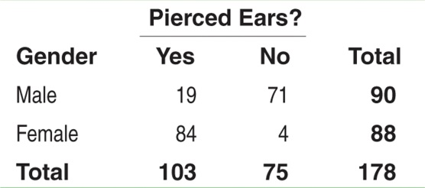

Find the probability that a student

1. has pierced ears.
2. is a male with pierced ears.
3. is a male or has pierced ears.

The last example illustrates the fact that we can’t use the addition rule for mutually exclusive events if there are outcomes in common.

**General Addition Rule for Two Events**

If *A* and *B* are any two events resulting from some chance process, then

*P*(*A* or *B*) = *P*(*A*) + *P*(*B*) – *P*(*A* and *B*)

**Example 1:**

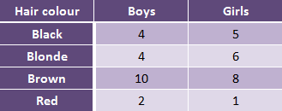

1. What is the probability a girl has blonde hair?
2. What is the probability a child with brown hair is a boy?
3. What is the probability a child is a girl or has red hair?

**Venn Diagrams and Probability**

The complement *AC* The events A and B are mutually exclusive (disjoint)

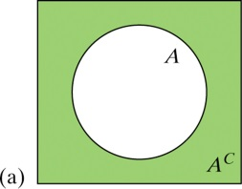 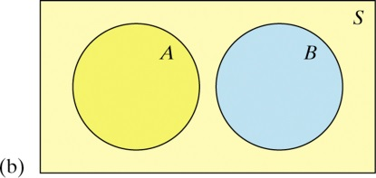

The intersection of events *A* and *B* (*A* ∩ *B*) The union of events *A* and *B* (*A* ∪ *B*)

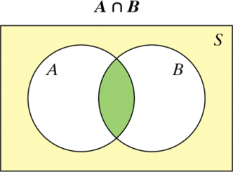 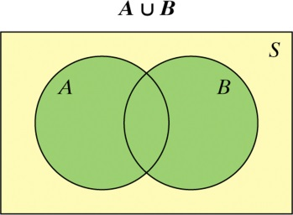

For the pierced ears example draw a Venn diagram:



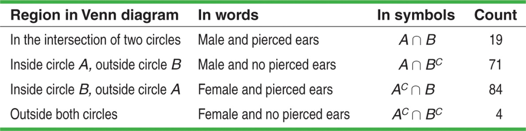

**Example 2:**

Out of forty students, 14 are taking English, 29 are taking Chemistry and 5 are taking both.

1. Draw a Venn diagram to represent this situation.
2. What is the probability a student is taking neither course?