4.1 Sampling and Surveys
Other Sampling Methods
Sometimes there are statistical advantages to using more complex sampling methods than an SRS. One common alternative to an SRS involves sampling important groups (called strata) within the population separately.
To select a stratified random sample, first classify the population into groups of similar individuals, called strata. Then choose a separate SRS in each stratum and combine these SRSs to form the full sample.
Although a stratified random sample can sometimes give more precise information about a population than an SRS, both sampling methods are hard to use when populations are large and spread out over a wide area. In that situation, we’d prefer a method that selects groups of individuals that are “near” one another.
To take a cluster sample, first divide the population into smaller groups. Ideally, these clusters should mirror the characteristics of the population. Then choose an SRS of the clusters. All individuals in the chosen clusters are included in the sample.
Example: Sampling at a School Assembly
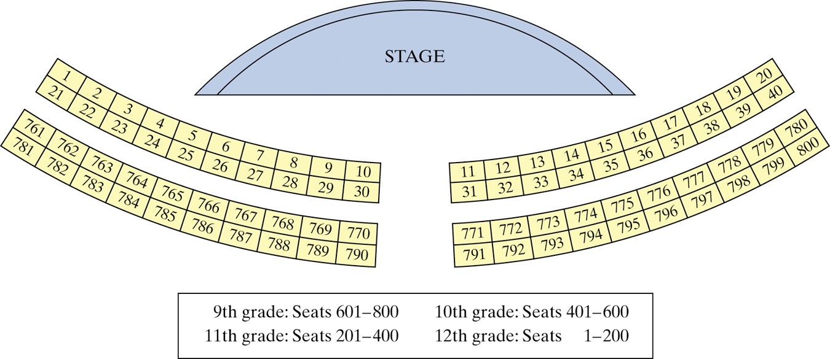
Describe how you would use the following sampling methods to select 80 students to complete a survey.
- Simple Random Sample

- Stratified Random Sample

- Cluster Sample

Example #2

The table shows the number of students in each year group at a school.

Grade | 9 | 10 | 11 | 12
No. of students | 190 | 145 | 145 | 120

Jenny is carrying out a survey for her AP Stats project. She uses a stratified
sample of 60 students according to grade.

- Calculate the number of Year 11 students that should be in her sample.

- Using line 118 in the random number table, find the first 3 students from each grade selected.

Sample Surveys: What Can Go Wrong?

Undercoverage occurs when some groups in the population are left out of the process of choosing the sample.

Nonresponse occurs when an individual chosen for the sample can’t be contacted or refuses to participate.

A systematic pattern of incorrect responses in a sample survey leads to response bias.

The wording of questions is the most important influence on the answers given to a sample survey.

