Normal Distribution
One particularly important class of density curves are the Normal curves, which describe Normal distributions.
- All Normal curves are symmetric, single-peaked, and bell-shaped
- A Specific Normal curve is described by giving its mean µ and standard deviation σ.
- We abbreviate the Normal distribution with mean µ and standard deviation σ as N(µ,σ).
The 68-95-99.7 Rule
- Approximately 68% of the observations fall within σ of µ.
- Approximately 95% of the observations fall within 2σ of µ.
- Approximately 99.7% of the observations fall within 3σ of µ.
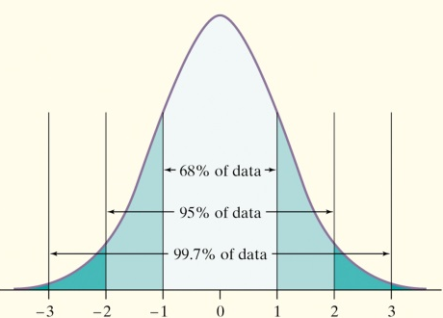
Example: 1 The distribution of Iowa Test of Basic Skills (ITBS) vocabulary scores for 7th grade students in Gary, Indiana, is close to Normal. Suppose the distribution is N(6.84, 1.55).
- Sketch the Normal density curve for this distribution.

- What percent of ITBS vocabulary scores are less than 3.74?
- What percent of the scores are between 5.29 and 9.94?
Example 2: The distribution of the heights of adult females is N(64.5, 2.5).
- Sketch the Normal density curve for this distribution.

- What percent of females are taller than 67 inches?
- What percent of females are between 59.5 inches and 64.5 inches?
The Standard Normal Distribution
The standard Normal distribution is the Normal distribution with mean 0 and standard deviation 1.
z =
The Standard Normal Table
Table A is a table of areas under the standard Normal curve. The table entry for each value z is the area under the curve to the left of z.
Examples: P(z < 0.81) =
P(z > 0.81) =
P(z < -1.25) =
Find the proportion of observations from the standard Normal distribution that are between -1.25 and 0.81.

When Tiger Woods hits his driver, the distance the ball travels can be described by N(304, 8). What percent of Tiger’s drives travel between 305 and 325 yards?

