**Section 1.3 – Describing Quantitative Data with Numbers**

|  |  |  |  |
| --- | --- | --- | --- |
| **Sample** | **Males (B)** | **Sample** | **Males (B)** |
| 1 | **2** | 11 | **5** |
| 2 | **2** | 12 | **2** |
| 3 | **1** | 13 | **3** |
| 4 | **2** | 14 | **1** |
| 5 | **4** | 15 | **8** |
| 6 | **4** | 16 | **3** |
| 7 | **2** | 17 | **1** |
| 8 | **2** | 18 | **2** |
| 9 | **1** | 8 | **2** |
| 10 | **2** | 20 | **5** |

**Data Set**: Random samples of size 10 to determine proportion of male hyenas in Croatan NF pack.

**Measuring Center: The Mean**

To find the **mean**  (pronounced “x-bar”) of a set of observations, add their values and divide by the number of observations.

**____________________________________________________________________________________**

**Measuring Center: The Median**

The **median M** is the midpoint of a distribution, the number such that half of the observations are smaller and the other half are larger.

To find the median of a distribution:

1. Arrange all observations from smallest to largest.
2. If the number of observations *n* is odd, the median *M* is the center observation in the ordered list.
3. If the number of observations *n* is even, the median *M* is the average of the two center observations in the ordered list.

Find the median of the number of males:

**Comparing the Mean and Median**

* The mean and median of a *roughly symmetric* distribution will be close together.
* If the distribution is *exactly symmetric*, the mean and median will be exactly the same.
* **In a *skewed* distribution, the mean is usually farther out in the long tail than the median.**

**Check your understanding**

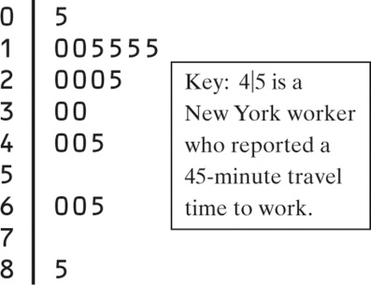

1. What is the shape of the distribution?
2. What is the median?
3. Will the mean be smaller or larger than the median (don’t calculate)
4. Confirm your answer by calculating the mean
5. Is the mean or median a better measure of center?

**Measuring Spread: The Interquartile Range (IQR)**

Procedure: (1) Arrange data in order; (2) Q1 is the median of the values left of the median; (3) Q3 is the median of the values right of the median; (4) IQR = Q3 – Q1.

Example: **1 1 1 1 1 2 2 2 2 2 2 2 2 3 3 4 4 5 5 8**

**Identifying Outliers** – An observation that falls more than 1.5 x IQR above Q3 or below Q1 is considered an *outlier*.

Example: