Least-Squares Regression (pp.164-188)

**Regression Line**

A **regression line** is a line that describes how a response variable *y* changes as an explanatory variable *x* changes. We often use a regression line to predict the value of *y* for a given value of *x*.

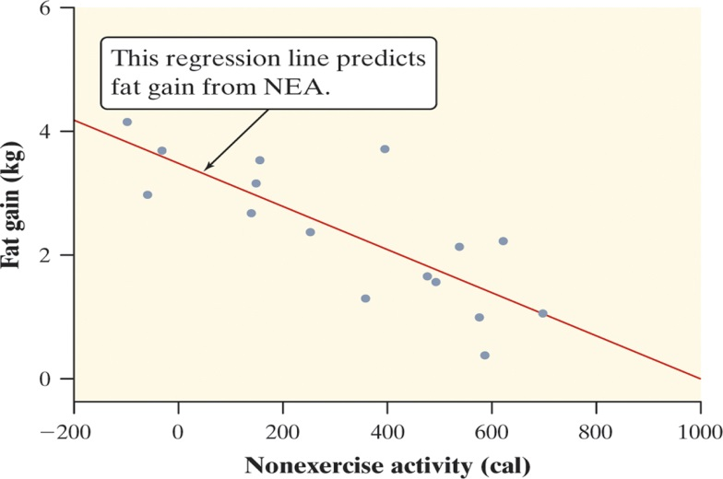

Figure 3.7 on page 165 is a scatterplot of the change in nonexercise activity (cal) and measured fat gain (kg) after 8 weeks for 16 healthy young adults.

* The plot shows a moderately strong, negative, linear association between NEA change and fat gain with no outliers.
* The regression line predicts fat gain from change in NEA.

What fat gain would you predict 800 cal of nonexercise activity?

**Interpreting a Regression Line**

A **regression line** relating *y* to *x* has an equation of the form

* *ŷ* (read “y hat”) is the **predicted value** of the response variable *y* for a given value of the explanatory variable x.
* *b* is the **slope**, the amount by which *y* is predicted to change when *x* increases by one unit.
* *a* is the **y intercept**, the predicted value of *y* when *x* = 0.

For the graph above,



What is the expected fat gain for 400 calories of NEA using the formula? 800 calories?

**Extrapolation**

**Extrapolation** is the use of a regression line for prediction far outside the interval of values of the explanatory variable *x* used to obtain the line. Such predictions are often not accurate.

Example

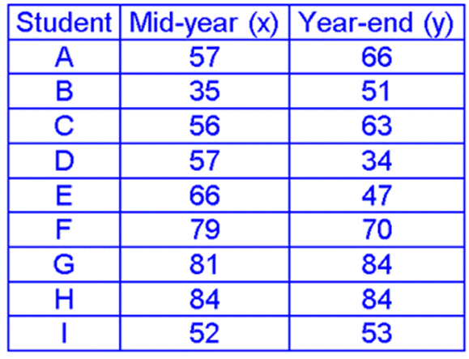

1. Draw the scatterplot
2. Draw the regression line
3. Find its equation
4. Predict the yearend grade for a student who had a 70 at midyear.
5. Predict the yearend grade for a student who had a 15 at midyear.Why should we be cautious about this value?

Assignment

|  |  |
| --- | --- |
| **Ice Cream Sales vs Temperature**   1. Draw the scatterplot 2. Draw an estimated line of best fit 3. Find its equation 4. Predict the sales for a temperature of 200 5. Predict the sales for a temperature of 300. Why should we be cautious about this value? | |
| **Temperature °C** | Ice Cream Sales |
| **14.2°** | $215 |
| **16.4°** | $325 |
| **11.9°** | $185 |
| **15.2°** | $332 |
| **18.5°** | $406 |
| **22.1°** | $522 |
| **19.4°** | $412 |
| **25.1°** | $614 |
| **23.4°** | $544 |
| **18.1°** | $421 |
| **22.6°** | $445 |
| **17.2°** | $408 |