Income Tax Review Name ________________________

- When do you use each of the following tax forms:
- 1040EZ

- 1040A

- 1040

- What is the difference between a W-2 and a 1099?

- How are each of the following filing statuses used:
  - Single

  - Married filing joint

  - Married filing separate

  - Head of household

- What do the following terms mean?
  - Gross pay

  - Net pay

  - Take-home pay

- How do you calculate exemptions and how does it affect your taxable income?

- What types of income is income tax paid on?

- John had $14,350 in medical expenses last year and has no medical insurance. The IRS allows medical expense deductions for the amount that exceeds 7.5% of a taxpayer’s adjusted gross income. If his adjusted gross income is $43,300, how much can he claim as a medical deduction?

- Look at the W-2 below. What is the total amount of federal, state, and local taxes that were withheld?
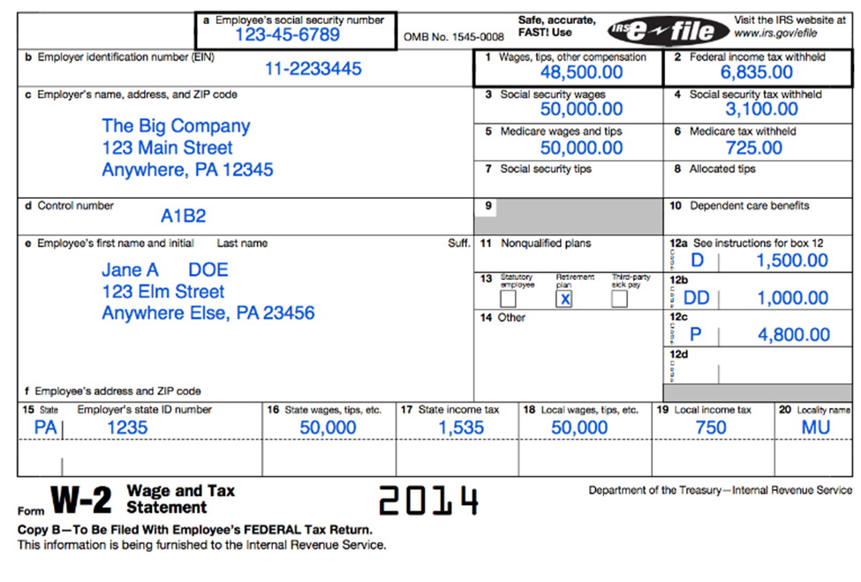

- Ann is a single mother with three children. She qualifies to file as head of household. Her total income before deductions was $44,600 last year. Her total deductions were $14,480. Use the tax table to determine how much Lynn will owe in taxes?

- Diane’s taxable income is $25,700. Using the tax schedule below, how much tax does she owe? 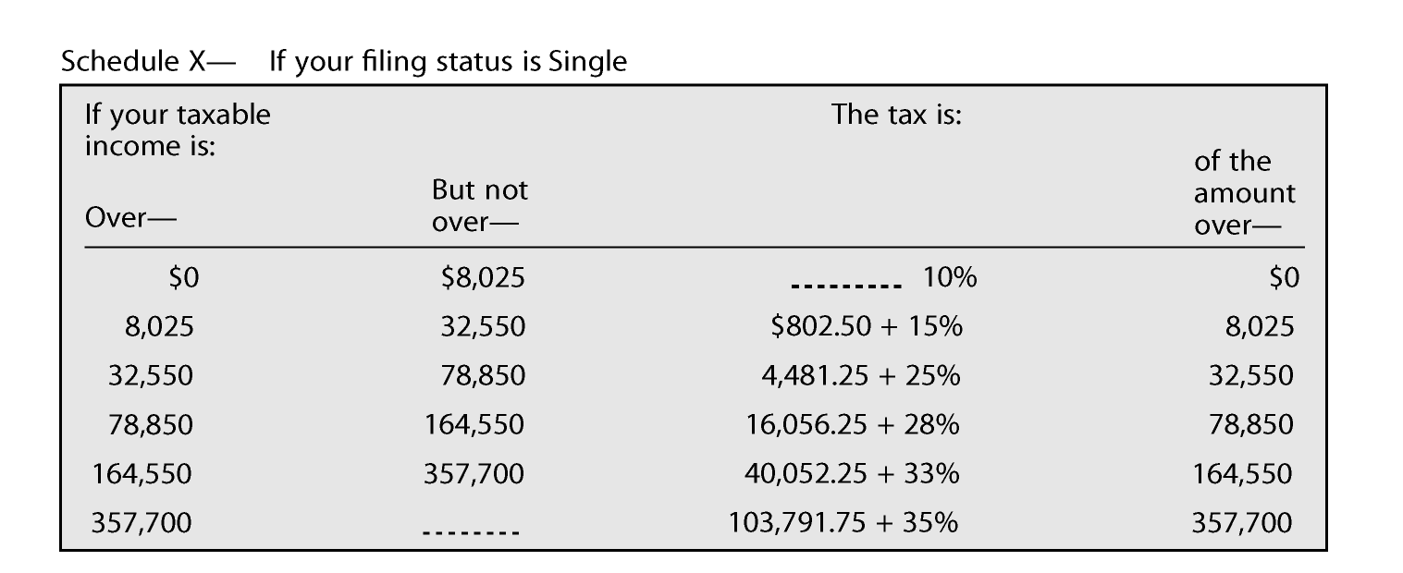

- Elvira verifying the accuracy of her paycheck. She earns $15 an hour and works 35 hours each week. Her weekly deductions are Social Security 6.2%, Medicare 1.45%, federal withholding tax $31.25, state withholding tax $9.75, and health insurance $15.15. What is her net pay if she is paid weekly?

- Alexis’ taxable income is $58,421. She is married, filing jointly. Find her tax using the tax tables.

- Tristan and Armani have a combined income of $84,221. They have 1099 forms which report $1,342 in interest. They also have $3,578 income from dividends. They are able to reduce their income by a $2,500 adjustment for moving expenses. What is their adjusted gross income?

- Abby is a single taxpayer whose total income before deductions is $87,934. She was able to reduce her total income by $12,220 by filing Schedule A. Use the tax rate schedule below. How much does she pay in taxes?

