Analyzing Quantitative Data

Histograms
- Divide the range of data into classes of equal width.
- Find the count (frequency) or percent (relative frequency) of individuals in each class.
- Label and scale your axes and draw the histogram. The height of the bar equals its frequency. Adjacent bars should touch, unless a class contains no individuals.
Percent of foreign-born residents by state
Frequency Table
Class | Count
0 to <5
5 to <10
10 to <15
15 to <20
20 to <25
25 to <30
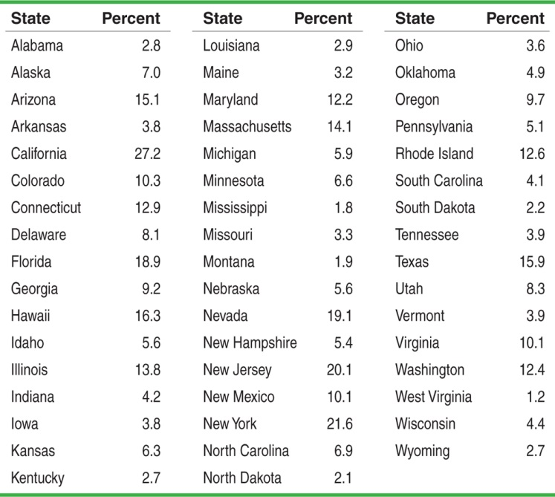

Using histograms wisely
- Don’t confuse histograms and bar graphs.
- Don’t use counts (in a frequency table) or percents (in a relative frequency table) as data.
- Use percents instead of counts on the vertical axis when comparing distributions with different numbers of observations.
- Just because a graph looks nice, it’s not necessarily a meaningful display of data.
Example #2
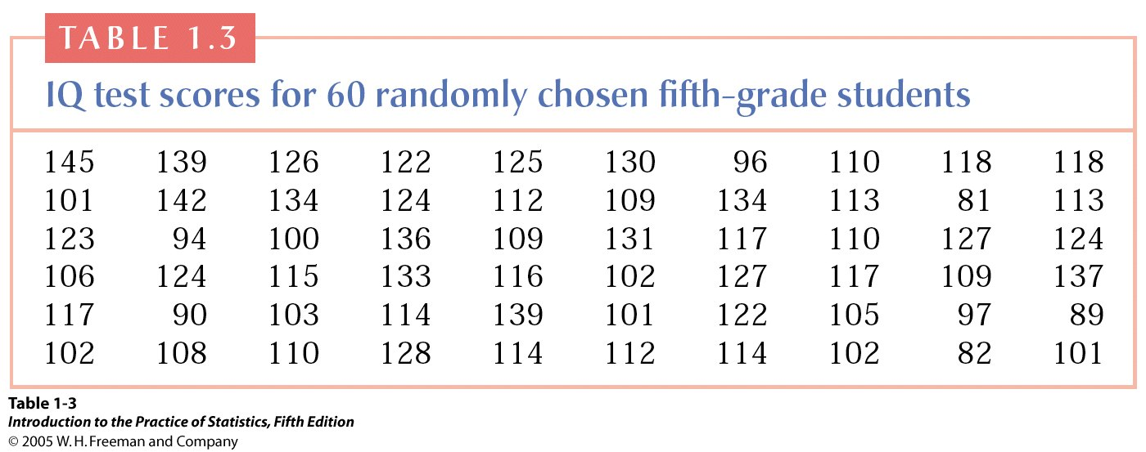
- Create a histogram for these scores (hint: use 10 as your class size)
- Many people believe that IQ scores follow a normal distribution or “bell curve”. Does your histogram support this?

