4.2 Experiments
Observational studies of the effect of one variable on another often fail because of confounding between the explanatory variable and one or more lurking variables.
A lurking variable is a variable that is not among the explanatory or response variables in a study but that may influence the response variable.
Confounding occurs when two variables are associated in such a way that their effects on a response variable cannot be distinguished from each other.
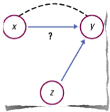
The Language of Experiments
An experiment is a statistical study in which we actually do something (a treatment) to people, animals, or objects (the experimental units) to observe the response. Explanatory variables are called factors. Here is the basic vocabulary of experiments.
A specific condition applied to the individuals in an experiment is called a treatment. If an experiment has several explanatory variables, a treatment is a combination of specific values of these variables.
The experimental units are the smallest collection of individuals to which treatments are applied. When the units are human beings, they often are called subjects.
Example:
What are the effects of repeated exposure to an advertising message? Researchers believe the answer may be both the length of the ad and how often it is repeated. An experiment using college students was conducted. All subjects viewed a 40 minute TV program that included ads for a digital camera. Some subjects saw a 30 second commercial while others saw a 90 second coomercial. The same commercial was shown either 1, 2 or 3 times during the program. After viewing, all subjects answered questions about their recall of the ad.
- What are the experimental units?

- Identify the factors and response variable

- List all the treatments

More Examples:
1. School officials want to determine how effective Project 2400 is for preparing students for the SAT. 30 college-bound juniors were selected. 15 participated in Project 2400 and the other 15 were left to prepare for the SAT on their own. After the SAT was taken, scores were compared.
- What are the experimental units?
- Identify the factors and response variable

- List all the treatments

2. A clothing manufacturer is setting up a new denim line. To test possible looks, the finishing machine will use either metal or bristle rollers, have a dyeing time of either 30 or 40 minutes and run at a temperature of either 150 or 175 degrees Celcius. How many treatments are there?

How to Experiment Well: The Randomized Comparative Experiment
If the treatments are given to groups that differ greatly, bias will result. The solution to the problem of bias is random assignment.
In an experiment, random assignment means that experimental units are assigned to treatments at random, that is, using some sort of chance process.
In a completely randomized design, the treatments are assigned to all the experimental units completely by chance.
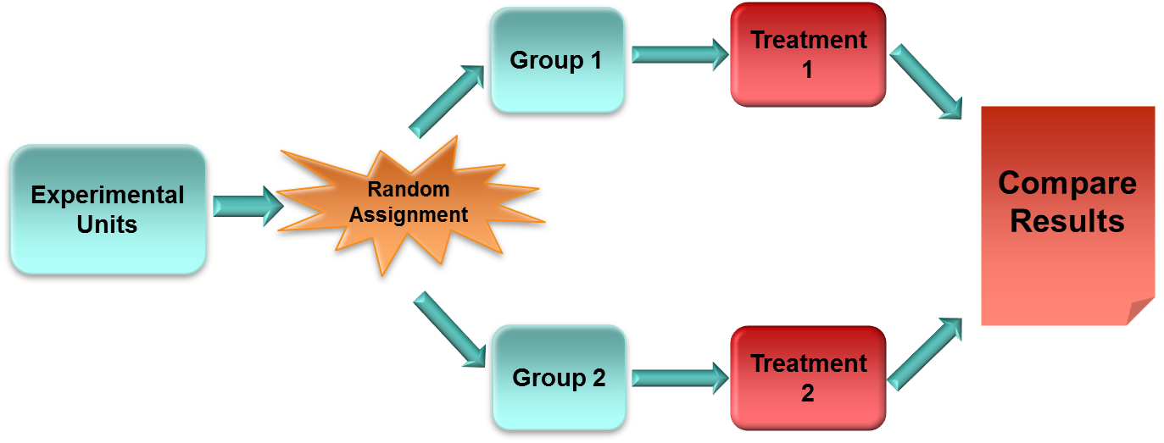

Example 1
School officials want to determine how effective Project 2400 is for preparing students for the SAT. 30 college-bound juniors were selected and randomly assigned to one of two groups. 15 participated in Project 2400 and the other 15 were left to prepare for the SAT on their own. After the SAT was taken, scores were compared. Draw the experimental design.

Example 2
An electric company wants to determine the effect of consumer information on energy conservation. One alternative is to install a digital display inside the house to show electricity usage. A second, cheaper, alternative is to provide a chart to the customer so they can go outside and record usage numbers from the meter. A control group will receive information on energy conservation but no tools. Outline a completely randomized experiment involving 60 families.

