Analyzing Quantitative Data

Dotplots

1. Draw a horizontal axis (a number line) and label it with the variable name.
2. Scale the axis from the minimum to the maximum value.
3. Mark a dot above the location on the horizontal axis corresponding to each data value.

|  |  |  |  |  |  |  |  |  |  |  |  |  |  |  |  |  |
| --- | --- | --- | --- | --- | --- | --- | --- | --- | --- | --- | --- | --- | --- | --- | --- | --- |
| **Number of Goals Scored Per Game by the 2004 US Women’s Soccer Team** | | | | | | | | | | | | | | | | |
| 3 | 0 | 2 | 7 | 8 | 2 | 4 | 3 | 5 | 1 | 1 | 4 | 5 | 3 | 1 | 1 | 3 | |
| 3 | 3 | 2 | 1 | 2 | 2 | 2 | 4 | 3 | 5 | 6 | 1 | 5 | 5 | 1 | 1 | 5 | |

Draw a dotplot

Describing a Graph

When examining a distribution, you can describe the overall pattern by its

**S_____ O_____ C_____ S_____**

Shape

A distribution is roughly **symmetric** if the right and left sides of the graph are approximately mirror images of each other.

A distribution is **skewed to the right** (right-skewed) if there is a tail towards the right side of the graph

It is **skewed to the left** (left-skewed) if there is a tail towards the left side of the graph

1. If a distribution is *symmetric*, what does it look like?
2. If a distribution is *skewed to the right*, what does it look like?

Comparing Distributions



Compare the distributions of household size for these two countries. Don’t forget your SOCS!

**Place**

**U.K South Africa**

Stemplots

1. Data will be separated into a **stem** (all but the final digit) and a **leaf** (the final digit).
2. Write all possible stems from the smallest to the largest in a vertical column and draw a vertical line to the right of the column.
3. Write each leaf in the row to the right of its stem, arranging the leaves in increasing order out from the stem.
4. Provide a key that explains in context what the stems and leaves represent.

These data represent the responses of 20 female AP Statistics students to the question, “How many pairs of shoes do you have?” Construct a stemplot.

|  |  |  |  |  |  |  |  |  |  |
| --- | --- | --- | --- | --- | --- | --- | --- | --- | --- |
| 50 | 26 | 26 | 31 | 57 | 19 | 24 | 22 | 23 | 38 |
| 13 | 50 | 13 | 34 | 23 | 30 | 49 | 13 | 15 | 51 |

Splitting Stems and Back-to-Back Stemplots

* When data values are “bunched up”, we can get a better picture of the distribution by **splitting stems**.
* Two distributions of the same quantitative variable can be compared using a **back-to-back stemplot** with common stems.

Female pairs of shoes

|  |  |  |  |  |  |  |  |  |  |
| --- | --- | --- | --- | --- | --- | --- | --- | --- | --- |
| 50 | 26 | 26 | 31 | 57 | 19 | 24 | 22 | 23 | 38 |
| 13 | 50 | 13 | 34 | 23 | 30 | 49 | 13 | 15 | 51 |

Males pairs of shoes

|  |  |  |  |  |  |  |  |  |  |
| --- | --- | --- | --- | --- | --- | --- | --- | --- | --- |
| 14 | 7 | 6 | 5 | 12 | 38 | 8 | 7 | 10 | 10 |
| 10 | 11 | 4 | 5 | 22 | 7 | 5 | 10 | 35 | 7 |

Draw a split back-to-back stemplot for female and male shoes and compare the distributions

1. 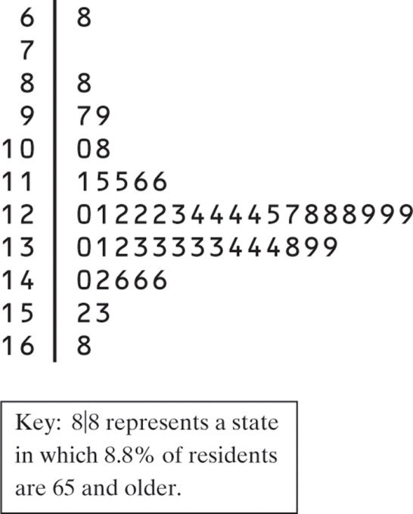The low outlier is Alaska. What percent of Alaska residents are 65 or over?
2. What is the shape of the distribution (ignore the outlier)?
3. What is the center of the distribution?