6.1 Discrete and Continuous Random Variables
Random Variable and Probability Distribution
A random variable takes numerical values that describe the outcomes of some chance process. The probability distribution of a random variable gives its possible values and their probabilities.
Consider tossing a fair coin 3 times.
Define X = the number of heads obtained
Value | 0 | 1 | 2 | 3
Probability
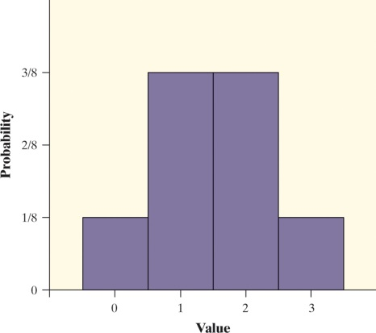
Discrete Random Variables
There are two main types of random variables: discrete and continuous. If we can find a way to list all possible outcomes for a random variable and assign probabilities to each one, we have a discrete random variable.
A discrete random variable X takes a fixed set of possible values with gaps between. The probability distribution of a discrete random variable X lists the values x_{i} and their probabilities p_{i}:
Value: x₁ x₂ x₃ …
Probability: p₁ p₂ p₃ …
The probabilities p_{i} must satisfy two requirements:
- Every probability p_{i} is a number between 0 and 1.
- The sum of the probabilities is 1.
To find the probability of any event, add the probabilities p_{i} of the particular values x_{i} that make up the event.

Example: Babies’ Health at Birth
The Apgar scale is used to rate a baby’s health at birth. It is based on 5 criteria: skin color, heart rate, muscle tone, breathing and response to stimulation. Each criteria is scored as a 0, 1 or 2 and the Apgar score is the total, with a range of 0 to 10.
The following table represents the scores of over 2 million babies:
Value: | 0 | 1 | 2 | 3 | 4 | 5 | 6 | 7 | 8 | 9 | 10
Probability: | 0.001 | 0.006 | 0.007 | 0.008 | 0.012 | 0.020 | 0.038 | 0.099 | 0.319 | 0.437 | 0.053
- Show that the probability distribution for X is legitimate.

- Make a histogram of the probability distribution. Describe what you see.

- Apgar scores of 7 or higher indicate a healthy baby. What is P(X ≥ 7)?

Mean of a Discrete Random Variable
Suppose that X is a discrete random variable whose probability distribution is
Value: x₁ x₂ x₃ …
Probability: p₁ p₂ p₃ …
To find the mean (expected value) of X, multiply each possible value by its probability, then add all the products:
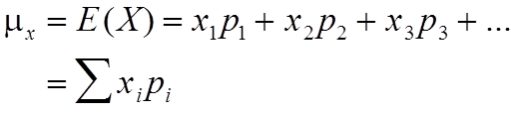

Example: Probability distribution for the sales department of a manufacturing company
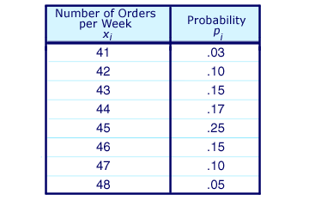
Compute the mean of the random variable Number of Orders per Week.

Standard Deviation of a Discrete Random Variable
Since we use the mean as the measure of center for a discrete random variable, we’ll use the standard deviation as our measure of spread. The definition of the variance of a random variable is similar to the definition of the variance for a set of quantitative data.
Suppose that X is a discrete random variable whose probability distribution is
Value: x₁ x₂ x₃ …
Probability: p₁ p₂ p₃ …
and that is the mean of X. The variance of X is

To get the standard deviation of a random variable, take the square root of the variance.
Example:
Compute the standard deviation of the random variable Number of Orders per Week.X

Using the calculator
In Lists & Spreadsheets, put the X values in Column A and the corresponding probabilities in column B.
Label both columns
Menu – Statistics – Stat Calculations – One Variable Statistics – OK (for 1 list)
X1 List – Label for column A; Frequency List – Label for column B; 1st Result Column – c[]; OK

Continuous Random Variables
A continuous random variable X takes on all values in an interval of numbers. The probability distribution of X is described by a density curve. The probability of any event is the area under the density curve and above the values of X that make up the event.
A continuous random variable Y has infinitely many possible values. All continuous probability models assign probability 0 to every individual outcome. Only intervals of values have positive probability.
Example:
Define Y as the height of a randomly chosen young woman. Y is a continuous random variable whose probability distribution is N(64, 2.7).
What is the probability that a randomly chosen young woman has height between 68 and 70 inches?
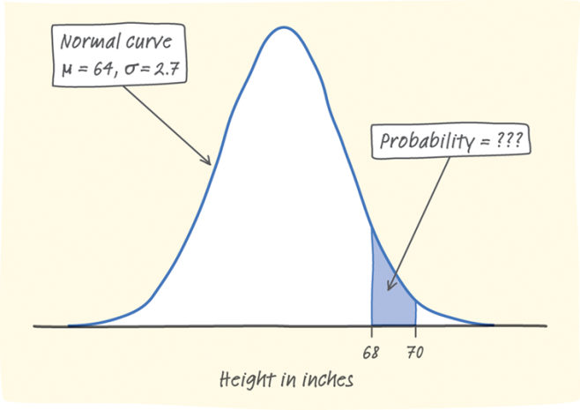
P(68 ≤ Y ≤ 70) = ???

