Interpreting Scatterplots
As in any graph of data, look for the overall pattern and for striking departures from that pattern.
- You can describe the overall pattern of a scatterplot by the direction, form, and strength of the relationship.
- An important kind of departure is an outlier, an individual value that falls outside the overall pattern of the relationship.
Direction – Positive or negative
Strength – the closer the points are to the line or curve that represents the middle, the stronger it is
Form – linear, curved
Examples
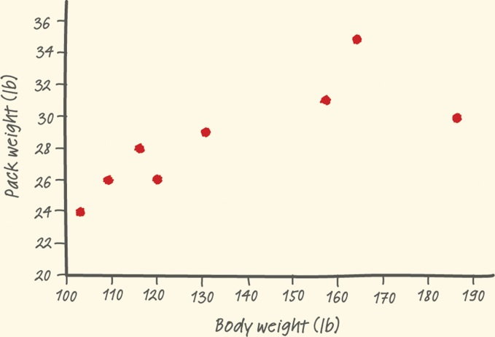

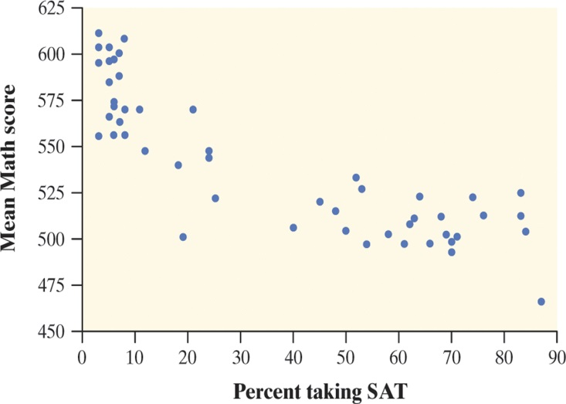
Measuring Linear Association: Correlation
Linear relationships are important because a straight line is a simple pattern that is quite common. Unfortunately, our eyes are not good judges of how strong a linear relationship is.
The correlation r measures the strength of the linear relationship between two quantitative variables.
  - r is always a number between -1 and 1
  - r > 0 indicates a positive association.
  - r < 0 indicates a negative association.
  - Values of r near 0 indicate a very weak linear relationship.
  - The strength of the linear relationship increases as r moves away from 0 towards -1 or 1.
  - The extreme values r = -1 and r = 1 occur only in the case of a perfect linear relationship.

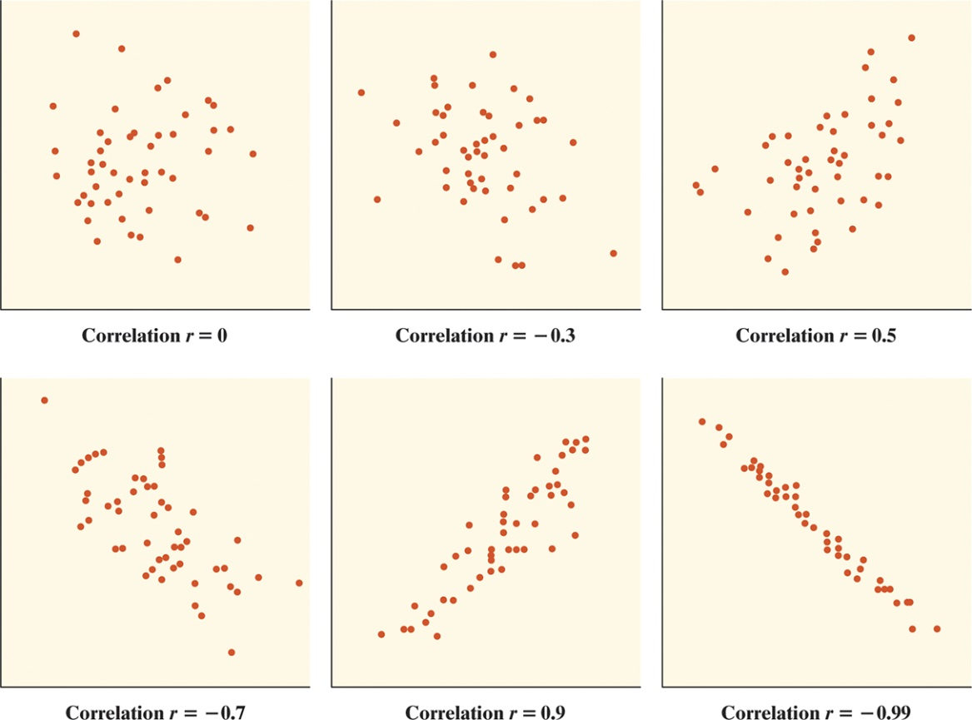

Using the Calculator for Scatterplots and Correlation
Body weight (lb) | 120 | 187 | 109 | 103 | 131 | 165 | 158 | 116
Backpack weight (lb) | 26 | 30 | 26 | 24 | 29 | 35 | 31 | 28
Draw the scatterplot and find the correlation r on your calculator:
Home ---> 1 New Document ---> No
Add Lists & Spreadsheet
In Column A you enter your explanatory variable (remember label at top)
In Column B you enter your response variable (remember label at top)
- Make sure corresponding values are in the same row
Home ---> Add Data & Statistics
Drag cursor to bottom rectangle, click and choose your explanatory variable
Drag cursor to left rectangle, click and choose your response variable
The scatterplot is created!!
Home ---> Add Calculator
Menu ----> 6 Statistics ---> 1 Stat Calculations ---> 3 Linear Regression
For X List, hit right arrow and choose explanatory variable from list
Tab to Y List, hit right arrow and choose response variable from list
Tab to Save Regeqn to: and delete what is in box
OK
The correlation r is one of the values shown!
Example

The table shows the number y (in thousands) of alternative-fueled vehicles in use in the United States x years after 1997. Use your calculator to draw a scatterplot and find correlation r.
x | 0 | 1 | 2 | 3 | 4 | 5 | 6 | 7
y | 280 | 295 | 322 | 395 | 425 | 471 | 511 | 548

Facts about Correlation

- Correlation makes no distinction between explanatory and response variables.
- r does not change when we change the units of measurement of x, y, or both.
- The correlation r itself has no unit of measurement.
- Correlation does not describe curved relationships between variables, no matter how strong the relationship is.
- Correlation is not resistant. r is strongly affected by a few outlying observations.

Assignment (Hand in on separate sheet)
- What would the explanatory and response variables be?
- Draw a scatterplot
- Find the correlation r
- How would you describe this relationship?

Ice Cream Sales vs Temperature
Temperature °C | Ice Cream Sales
14.2° | $215
16.4° | $325
11.9° | $185
15.2° | $332
18.5° | $406
22.1° | $522
19.4° | $412
25.1° | $614
23.4° | $544
18.1° | $421
22.6° | $445
17.2° | $408

