5.3 What are the Chances
What is Conditional Probability?
When we are trying to find the probability that one event will happen under the condition that some other event is already known to have occurred, we are trying to determine a conditional probability.
Suppose we know that event A has happened. Then the probability that event B happens given that event A has happened is denoted by P(B | A).
Example 1:
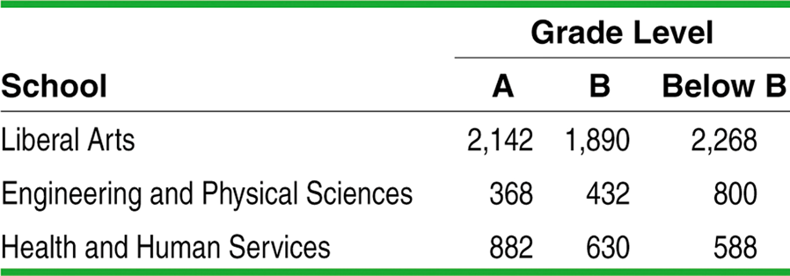
Define events
E: the grade comes from an Engineering and Physical Science course, and
L: the grade is lower than a B.
- Find P(L)

- Find P(E|L)

- Find P(L|E)

Example 2:
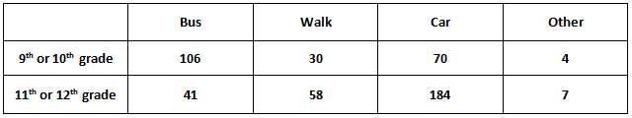
- Find the probability a student takes a car to school
- Find the probability that a student is an 11th or 12th grader given that they take a car to school
- Find the probability a student takes a bus given they are a 9th or 10th grader

Conditional Probability and Independence
When knowledge that one event has happened does not change the likelihood that another event will happen, we say the two events are independent.
Two events A and B are independent if the occurrence of one event has no effect on the chance that the other event will happen. In other words, events A and B are independent if
P(A | B) = P(A) and P(B | A) = P(B).
Example 3:
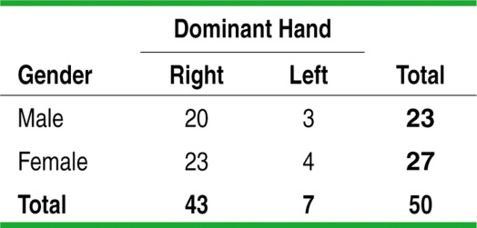
Are the events “male” and “left-handed” independent? Justify your answer.
Example 4:
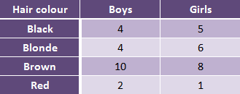
Tree Diagrams
A way to model chance behavior that involves a sequence of outcomes is to construct a tree diagram.
Consider flipping a coin twice. Draw a tree diagram to illustrate these events

What is the probability of getting two heads?

General Multiplication Rule
The idea of multiplying along the branches in a tree diagram leads to a general method for finding the probability P(A ∩ B) that two events happen together.
The probability that events A and B both occur can be found using the general multiplication rule
P(A ∩ B) = P(A) • P(B | A)
where P(B | A) is the conditional probability that event B occurs given that event A has already occurred.
If A and B are independent, then P(B | A) = P(B)
Example 1:
The Pew Internet and American Life Project finds that 93% of teenagers (ages 12 to 17) use the Internet, and that 55% of online teens have posted a profile on a social-networking site.
What percent of teens are online and have posted a profile? Use a tree diagram to help find the answer.

Example 2:
A study found that 27% of adult Internet users are 18-29, 45% are 30-49 and 28% are over 50. Another study found that 70% of Internet users in the 18-29 range have visited Youtube, 51% of Internet users 30-49 have visited Youtube and 26% of Internet users over 50 have visited Youtube.
What percent of all adult Internet users visit YouTube?

Example 3:
