  - Analyzing Categorical Data

Conditional Distributions
A Conditional Distribution of a variable describes the values of that variable among individuals who have a specific value of another variable.
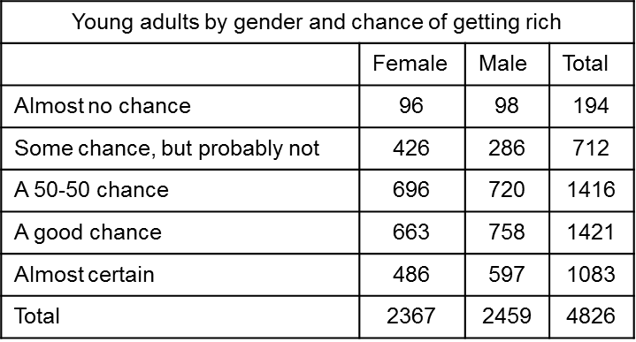

- Calculate the conditional distribution of opinion among males.

- Calculate the conditional distribution of opinion among females.

- Compare these two conditional distributions

- Calculate the conditional distribution of gender among the opinion “a 50-50 chance”

- Calculate the conditional distribution of gender among the opinion “some chance but probably not”
