**10.1 Comparing Two Proportions**

Suppose we want to compare the proportions of individuals with a certain characteristic in Population 1 and Population 2. Let’s call these parameters of interest *p1 and p2.* The ideal strategy is to take a separate random sample from each population and to compare the sample proportions with that characteristic*.*

What if we want to compare the effectiveness of Treatment 1 and Treatment 2 in a completely randomized experiment? This time, the parameters *p1 and p2* that we want to compare are the true proportions of successful outcomes for each treatment. We use the proportions of successes in the two treatment groups to make the comparison. Here’s a table that summarizes these two situations.

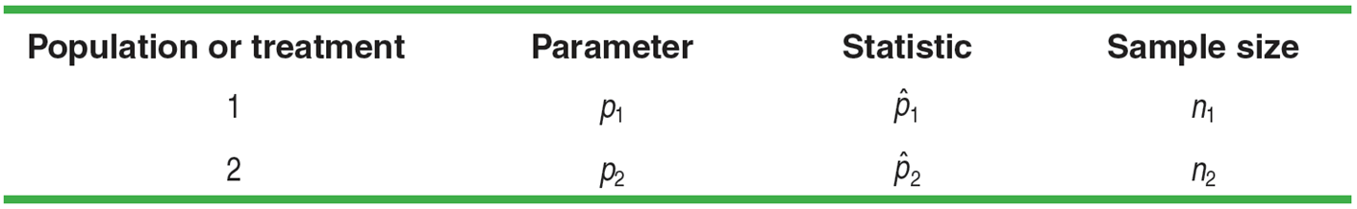

In Chapter 7, we saw that the sampling distribution of a sample proportion has the following properties:

**Shape** Approximately Normal if *np ≥* 10 and *n*(1 *- p*) *≥* 10





**The Sampling Distribution of a Difference Between Two Proportions**

Choose an SRS of size *n1* from Population 1 with proportion of successes

*p1* and an independent SRS of size *n2* from Population 2 with proportion of

successes *p2*.







**Example: Who Does More Homework?**

Suppose that there are two large high schools, each with more than 2000 students, in a certain town. At School 1, 70% of students did their homework last night. Only 50% of the students at School 2 did their homework last night. The counselor at School 1 takes an SRS of 100 students and records the proportion that did homework. School 2’s counselor takes an SRS of 200 students and records the proportion that did homework*.* School 1’s counselor and School 2’s counselor meet to discuss the results of their homework surveys. After the meeting, they both report to their principals that 







**Example: Who Does More Homework? – Part 2**

Suppose that two counselors at School 1, Michelle and Julie, independently take a random sample of 100 students from their school and record the proportion of students that did their homework last night. When they are finished, they find that the difference in their proportions  was 0.08. They were surprised to get a difference this big, considering they were sampling from the same population. Should they be surprised?

**Confidence Intervals for *p1 – p2***

Our confidence interval is always:

**



If the Normal condition is met, we find the critical value z* for the given confidence

level from the standard Normal curve. Our confidence interval for p1 – p2 is:



**Example: Teens and Adults on Social Networks**

As part of the Pew Internet and American Life Project, researchers conducted two surveys in late 2009. The first survey asked a random sample of 800 U.S. teens about their use of social media and the Internet. A second survey posed similar questions to a random sample of 2253 U.S. adults. In these two studies, 73% of teens and 47% of adults said that they use social-networking sites. Use these results to construct and interpret a 95% confidence interval for the difference between the proportion of all U.S. teens and adults who use social-networking sites. (use 4-step process)

**State parameters of interest:**

**Conditions:**

**Calculation:**

**Conclusion:**

**Example: Presidential Approval**

Many news organizations conduct polls asking adults in the United States if they approve of the job the president is doing. How did President Obama’s approval rating change from August 2009 to September 2010? According to a CNN poll of 1024 randomly selected U.S. adults on September 1-2, 2010, 50% approved of Obama’s job performance. A CNN poll of 1010 randomly selected U.S. adults on August 28-30, 2009 showed that 53% approved of Obama’s job performance. Use the results of these polls to construct and interpret a 90% confidence interval for the change in Obama’s approval rating among all US adults.