6.2 **Transforming and Combining Random Variables**

**Combining Random Variables**

**Adding two random variables**

Many interesting statistics problems require us to examine two or more random variables.

For any two random variables *X* and *Y*, if *T = X* + *Y*, then the expected value of *T* is

*E*(*T*) = *µT* = *µX* + *µY*

In general, the mean of the sum of several random variables is the sum of their means.

For any two *independent* random variables *X* and *Y*, if *T = X* + *Y*, then the variance of *T* is

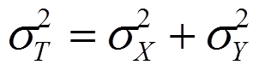

In general, the variance of the sum of several independent random variables is the sum of their variances.

*Remember that you can add variances only if the two random variables are independent, and that you can NEVER add standard deviations!*

Example:

Let *X* = the number of passengers on a randomly selected trip with Pete’s Jeep Tours. *Y* = the number of passengers on a randomly selected trip with Erin’s Adventures.

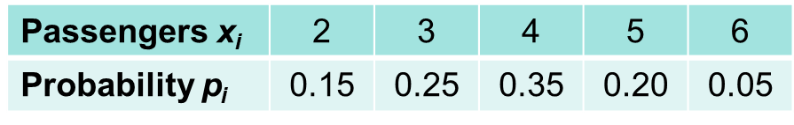

Mean *µX* = 3.75 Standard Deviation *σX* = 1.090

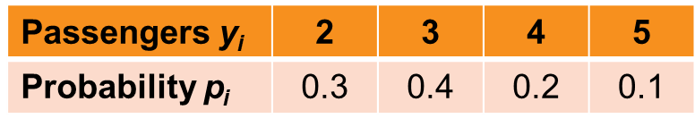

Find the mean and standard deviation for Erin’s Adventures

Define *T* = *X* + *Y.* What are the mean and standard deviation of *T*?

**Subtracting two random variables**

For any two random variables *X* and *Y*, if *D = X - Y*, then the expected value of *D* is

*E*(*D*) = *µD* = *µX* - *µY*

In general, the mean of the difference of several random variables is the difference of their means. *The order of subtraction is important!*

For any two *independent* random variables *X* and *Y*, if *D = X* - *Y*, then the variance of *D* is



In general, the variance of the difference of two independent random variables is the sum of their variances.

Example:

1. Assume Erin charges $175 per passenger. Find the mean and standard deviation for her daily collections
2. Find the mean and standard deviation for the difference between Pete’s daily collection and Erin’s daily collection. Remember that Pete’s daily collection had a mean of $562.50 and a standard deviation of $163.50.