Section 8.2 – Estimating a Population Proportion
Warmup
The U.S. Forest Service is considering additional restrictions on the number of vehicles allowed to enter Yellowstone National Park. To assess public reaction, the service asks a random sample of 150 visitors if they favor the proposal. Of these, 89 say “Yes.”
Are the conditions met for calculating a confidence interval?

Activity: Paper Clips
Your teacher has a bucket full of different colored paper clips. Your goal is to estimate the actual proportion of red paper clips in the bucket.
- Form teams of students.
- Determine how to get a simple random sample of paper clips from the bucket
- Each team is to collect one SRS of paper clips.
- Determine a point estimate for the unknown population proportion.
- Find a 90% confidence interval for the parameter p. Consider any conditions that are required for the methods you use.
- Compare your results with other students in the class
Point estimate:

Conditions:

Construct a 90% Confidence Interval:
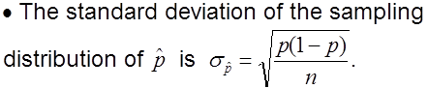

Finding a Critical Value
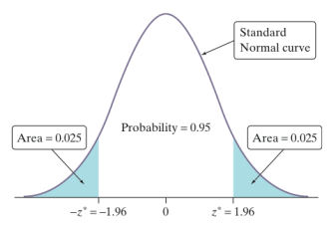
For example, to find a 95% confidence interval, we use a critical value of 2 based on the 68-95-99.7 rule. Using Table A or a calculator (menu 5-5-3), we can get a more accurate critical value.
Note, the critical value z* is actually 1.96 for a 95% confidence level.
For 90%, z*=
The 90% confidence interval is:

Other students’ results:

One-Sample z Interval for a Population Proportion
Our confidence interval for the population proportion p is:
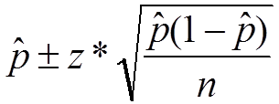
Example #1
After two games of the regular season, Lebron had made 17 of 45 shots attempted. Construct a 95% confidence interval for the proportion of shots that you would expect him to make for the season.

The Four-Step Process
State: What parameter do you want to estimate, and at what confidence level?
Plan: Identify the appropriate inference method. Check conditions.
Do: If the conditions are met, perform calculations.
Conclude: Interpret your interval in the context of the problem.
Example #2
Gallup asked a random sample of 439 U.S. teens whether they thought young people should wait to have sex until marriage. Of the sample, 246 said “Yes”. Construct a 90% confidence interval for the proportion of all teens who would say “Yes” to this question using the 4-step process.

Choosing the Sample Size
In planning a study, we may want to choose a sample size that allows us to estimate a population proportion within a given margin of error. The margin of error (ME) in the confidence interval for p is
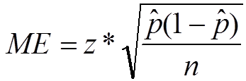
Rearranging the equation from above, the required sample size is:
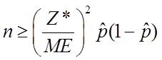
Example #1
A customer service manager wants to know the proportion of customers who are satisfied with their dealings with her company. Determine the sample size needed to estimate p within 0.03 with 95% confidence.

Example #2
The U. S. Crime Commission wants to estimate p = the proportion of crimes in which firearms are used to within .02 with 90% confidence. Data from previous years shows that p is about .6. Find the sample size required to get this margin of error.

