Chapter 2 Review AP Statistics Name:

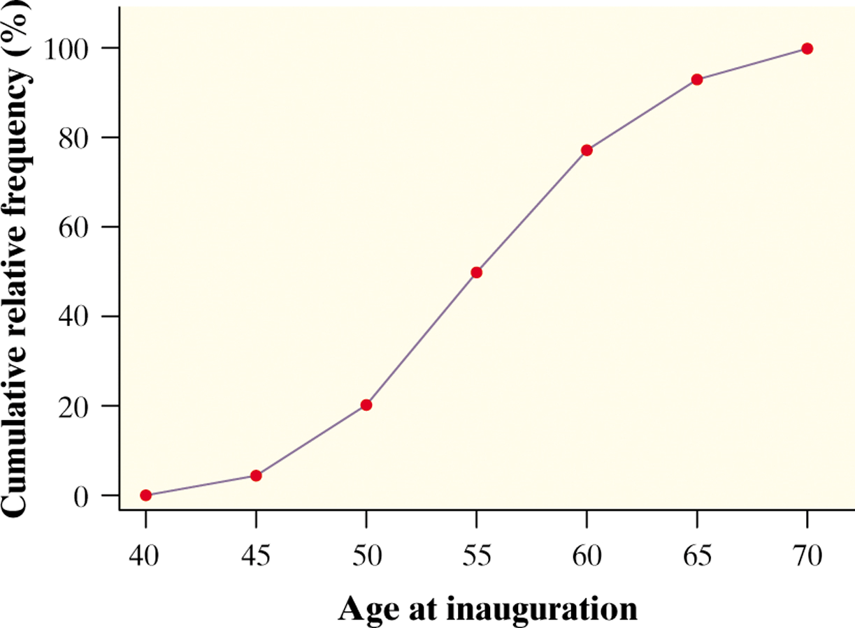
- What is the percentile for an age of 56? What is the age for the 20th percentile?

2. The scores on an IQ test are approximately Normally distributed with mean 100 and standard deviation 16. 68% of the test takers score within what range?

- For the density curve shown
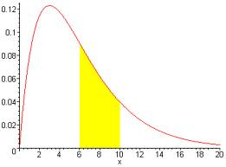
- What is the area under the curve?

- What is the shape of the curve?

- Which is larger, the mean or the median, or are they equal?

4. What is the area under the standard Normal curve corresponding to –2.14 < Z < 0.67?
5. Suppose that 500 students take the SAT test, and you find that your score of 550 is the 62nd percentile. What does this result mean?

6. Scores on the Wechsler Adult Intelligence Scale for the 20 to 34 age group are approximately Normally distributed with mean 110 and standard deviation 25. Scores for the 60 to 64 age group are approximately Normally distributed with mean 90 and standard deviation 25.
Sarah, who is 30, scores 135 on this test. Betty, who is Sarah's mother and is 60, also takes the test and scores 120.

(a) Find the z-scores for Sarah’s and Betty’s scores. Which person had the more impressive score? Explain briefly.

(b) Find the percentiles for Sarah’s and Betty’s scores

.

7. Below are cumulative frequency graphs for the age distributions of the populations of France and the Philippines.

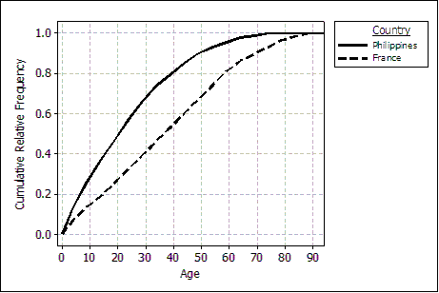

- What are the median and interquartile range for ages in France?

- For the Phillipines, the mean age is 35.4 with a standard deviation of 11.2. The researcher believes the birth records are not accurate so he wants to adjust the records by adding 3 months to each person’s age and therefore wants to express ages in months rather than years. What would the adjusted mean and standard deviation be?

8. The Acculturation Rating Scale for Mexican Americans (ARSMA) is a psychological test that measures the degree to which Mexican Americans are adapted to Mexican/Spanish versus Anglo/English culture. The range of possible scores is 1.0 to 5.0, with higher scores showing more Anglo/English acculturation. The distribution of ARSMA scores in a population used to develop the test is approximately Normal with mean 3.0 and standard deviation 0.8

(a) Sketch the distribution of ARSMA scores. Label the points one, two, and three standard deviations from the mean.

(b) What proportion of scores are between 2.2 and 3.8? Show your work.

- What proportion of scores are more than 3.5?

- Find the 70th percentile of ARSMA scores distribution. Show your method.

- What are the range of scores that make up the middle 40% of scores?

