Ch. 6 Formulas AP Statistics Name:

***Adding (or subtracting) a constant, a***

*µY* = *a* *+ µX*.

*σY* = *σX*

***Multiplying (or dividing) each observation by a constant, b:***

*µY* = *bµX*.

*σY* = |*b*|*σX*

**If *Y* = *a* + *bX***

*µY* = *a* *+ bµX*.

*σY* = |*b*|*σX*

**For any two random variables *X* and *Y*, if *T = X* + *Y***

*µT* = *µX* + *µY*

*then take square root*



**For any two random variables *X* and *Y*, if *D = X – Y***

*µD* = *µX* - *µY*

*then take square root*



**For random variables**



**For Binomial random variables**

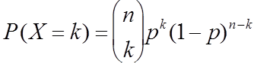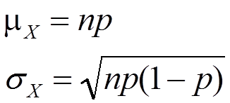

**For Geometric random variables**



*µY* = 1/*p*