AP Statistics Name _________________________________

Chapter 3

Review Date __________________Period ___________

1. A study is conducted to determine if one can predict the number of points scored in a football game based on the temperature at the start of the game. What is the response variable in this study?

**Use for questions 2-5**

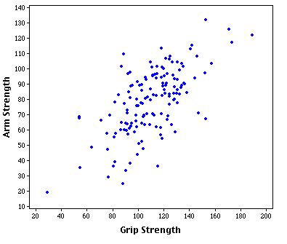



1. What is the explanatory variable?
2. What type of relationship is there between grip strength and arm strength?
3. Are there any outliers?
4. What could be a possible value for the correlation coefficient between grip strength and arm strength
5. 1 b) .7 c) .2 d) -.2 e) -.8
6. In general, what is the range of values for the correlation coefficient?
7. When will the correlation coefficient be equal to 1?
8. What is used to measure the percentage or proportion of variability between two variables?

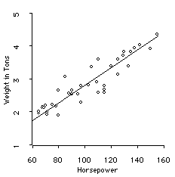

1. Based on the least squares regression line in the scatterplot above, a vehicle with 120 horsepower would weigh how many tons?

**Questions 10-13 relate to the following.**

For hamburgers at a fast food restaurant, a nutritionist says that you can predict fat grams from the number of protein grams.

**10.** What is the explanatory variable, and what is the response variable based on the context of the problem?

EXPLANATORY: RESPONSE:

To determine a formula for predicting the fat grams, data was collected and entered into the calculator. Here are some results:

 = 17.2  = 14.0  = 23.5  = 16.4 *r* = 0.83

**11.** Use this information to find the equation of the least-squares regression line. Show your work.

**12.** Using the equation you found above, what is the predicted fat grams if there are 15 grams of protein?

**13.** One of the hamburgers with 15 grams of protein was found to have 20 grams of fat. What is the residual for this data point?

**Questions 14-17 relate to the following.**

The table below describes the relationship between latitude and average July temperature in the twelve largest U.S. cities.

|  |  |  |
| --- | --- | --- |
| City | Latitude (*x*) | July Temp  (*y*) |
| New York | 40 | 77 |
| Los Angeles | 34 | 74 |
| Chicago | 42 | 75 |
| Houston | 29 | 84 |
| Philadelphia | 40 | 77 |
| Phoenix | 33 | 94 |
| San Diego | 32 | 71 |
| San Antonio | 29 | 85 |
| Dallas | 32 | 86 |
| San Jose | 37 | 70 |
| Detroit | 42 | 74 |
| Indianapolis | 39 | 75 |

14. Use your calculator to find the equation of the least-squares regression equation. Write the equation below

15. Anchorage, Alaska is at a latitude of 610. What do you predict the July temperature would be for Anchorage?

16. Is there any reason to be cautious about your prediction in question 15? Explain

17. What percent of the variability of July temperatures can be attributed to latitude?