AP Stats Name _____________________

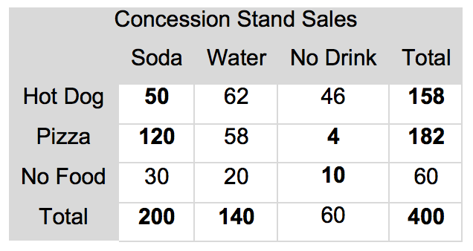
Using the table for Concession Stand Sales, find the following:
- The marginal distribution for drink sales

- The conditional distribution of food sales among soda drinkers

- The conditional distribution of drink sales among pizza eaters

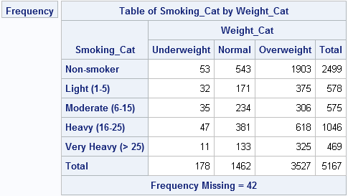
Using the table for Smoking by Weight, find the following:
- The marginal distribution for smoking category

- The conditional distribution of weight category among non-smokers

- The conditional distribution of smoking category among overweight people

