Warmup
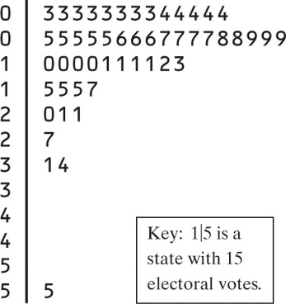
- What is the shape of the distribution? Will the mean be smaller or larger than the median (don’t calculate)
- What is the median?
- Calculate the IQR
- Confirm 55 is an outlier

Five-Number Summary & Boxplots
The 5-Number Summary consists of the miniumum observation, the first quartile, the median, the third quartile, and the maximum observation, written in order from smallest to largest.
Minimum Q₁ M Q₃ Maximum
Example:
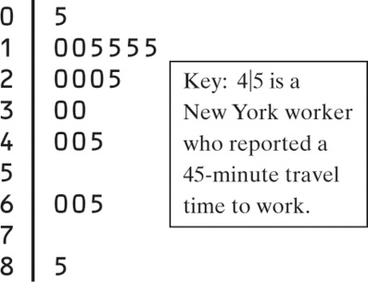
Calculate the 5-number summary

These numbers roughly divide the distribution into quarters.

A boxplot graphically depicts the 5-number summary.
- Draw and label a number line that includes the range of the distribution.
- Draw a central box from Q₁ to Q₃.
- Note the median M inside the box.
- Extend lines (whiskers) from the box out to the minimum and maximum values that are not outliers. Place a dot for outliers

Example: Draw the boxplot for the 5-number summary from above

Example
The number of calories in 22 different Ice Cream Bars
342, 377, 319, 353, 295, 234, 294, 286, 377, 182, 310, 439, 111, 201, 182, 197, 209, 147, 190, 151, 131, 151
- Find the 5-number summary for this data and draw a boxplot.
- Describe the distribution

Comparing Distributions of Data
This side by side boxplot shows the five number summary of annual salary from graduates of Renata College. The boxplot on top shows the salaries of graduates from two years ago, the boxplot on the bottom shows the salaries of graduates from five years
Compare the two distributions

Measuring Spread: The Standard Deviation
The standard deviation s_{x} measures the average distance of the
observations from their mean.
Procedure: 1) Calculate the mean.
2) Calculate each deviation.
deviation = observation – mean
3) Square each deviation.
4) Find the “average” squared deviation. Calculate the sum of the squared deviations divided by (n-1)…this is called the variance.
5) Calculate the square root of the variance…this is the standard deviation.
Example:
