6.3 Binomial and Geometric **Random Variables**

**Warmup**

A (blindfolded) marksman finds that on the average he hits the target 4 times out of 5. If he fires 4 shots, what is the probability of

1. exactly one hit?
2. more than 3 hits? (set up formula, don’t calculate)
3. less than 3 misses? (set up formula, don’t calculate)

**Mean and Standard Deviation of a Binomial Distribution**

We describe the probability distribution of a binomial random variable just like any other distribution – by looking at the shape, center, and spread. Consider the probability distribution of *X* = number of children with type O blood in a family with 5 children.

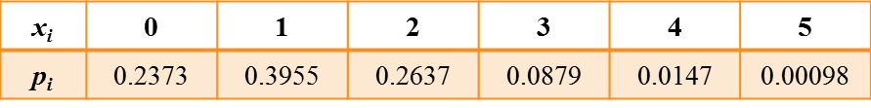

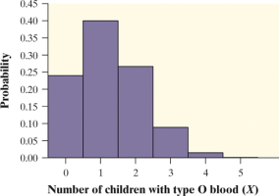 **Shape:**

**Mean:**

**Standard Deviation:**

If a count *X* has the binomial distribution with number of trials *n* and probability of success *p*, the **mean** and **standard deviation** of *X* are

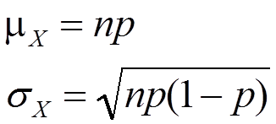

***Note: These formulas work ONLY for binomial distributions.They can’t be used for other distributions!***

Example: Bottled Water versus Tap Water

Mr. Nicol’s 21 AP Statistics students did the Activity on page 340, in which each tasted 3 cups of water, two with tap water and one with bottled water. If we assume the students in his class *cannot* tell tap water from bottled water, then each has a 1/3 chance of correctly identifying the different type of water by guessing. Let *X* = the number of students who correctly identify the cup containing the different type of water.

Find the mean and standard deviation of *X*.

**Binomial Distributions in Statistical Sampling**

Suppose 10% of CDs have defective copy-protection schemes that can harm computers. A music distributor inspects an SRS of 10 CDs from a shipment of 10,000. Let *X* = number of defective CDs.

Tthis is not quite a binomial setting. Why?

What is P(X = 0)?

**Sampling Without Replacement Condition**

When taking an SRS of size *n* from a population of size *N*, we can use a binomial distribution to model the count of successes in the sample as long as we don’t sample more than 10% of the population.



Example

A store wants to make sure a delivery of 100 Christmas trees are between the advertised height of 6’-7’. 15% of the trees are not within the height range. What is the probability that they will find at least 2 trees not within the height range if they take a random sample of 20 trees?