  - Analyzing Categorical Data

Basic Definitions

Individual – Objects described by a set of data. May be people, animals or things
Variable – any characteristic of an individual
Categorical variable - place individuals into one of several groups or categories (label)
Quantitative variable – takes numerical values for which it makes sense to find an average (measurement)

- A frequency table displays…

- A relative frequency table displays…

- What type of data are pie charts and bar graphs used for?

- Pie charts can only display __________________

Student Housing at Union University
Type of Housing | Number of Students
Residence Halls | 3995
Fraternity/Sorority Houses | 985
Off Campus Aparments | 2347
Off Campus Houses | 1093

Draw the following for this data:
Bar graph Pie chart

- What is a two-way table? describes two categorical variables, organizing counts according to a row variable and a column variable.

- The Marginal Distribution of one of the categorical variables in a two-way table of counts is the distribution of values of that variable among all individuals described by the table.
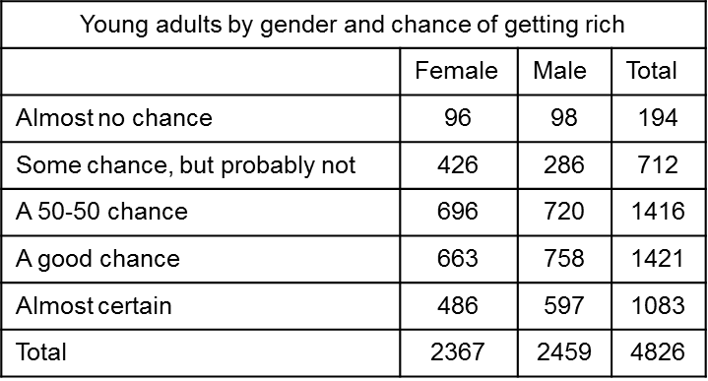

- What is the marginal distribution of chance of getting rich? Use a bar graph to display the data.

- What is the marginal distribution of gender? Use a bar graph to display the data.

